Line Symmetry

Definition
# Source: AI Source: Provided by: [Data Path: Persons Table -> ID Column: 1, Name_En Column: Motasem Essam] -> From: [ChatGPT] on [7/25/2026]
Line Symmetry is a type of symmetry in which a geometric figure can be divided by a line into two parts that are mirror images of each other.
The line that divides the figure is called the line of symmetry, axis of symmetry, or mirror line.
If a figure is reflected across its line of symmetry, the reflected image coincides exactly with the original figure.
$$\boxed{\text{Reflection across the line of symmetry}→\text{same figure}}$$
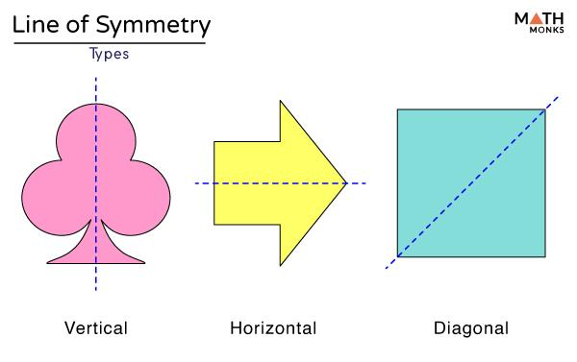
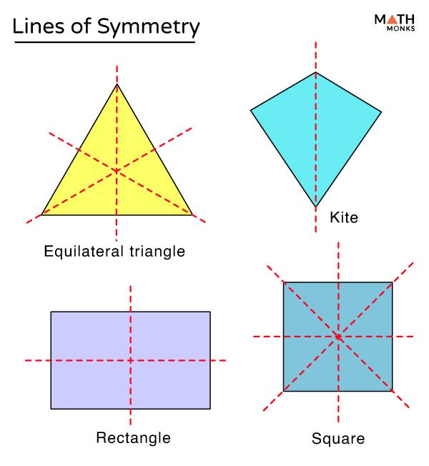
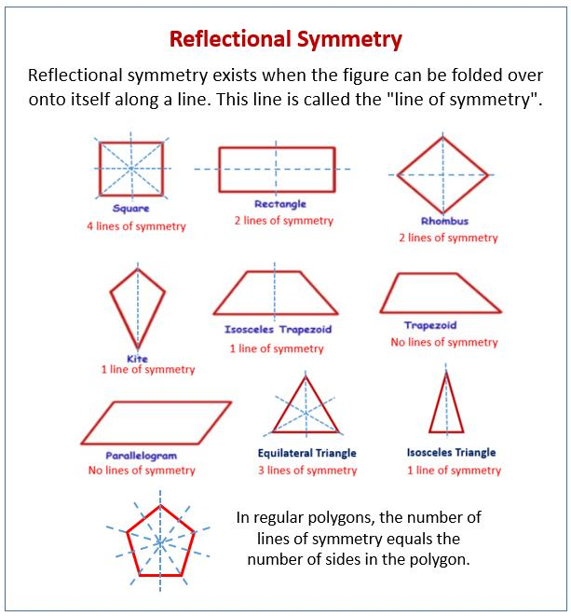
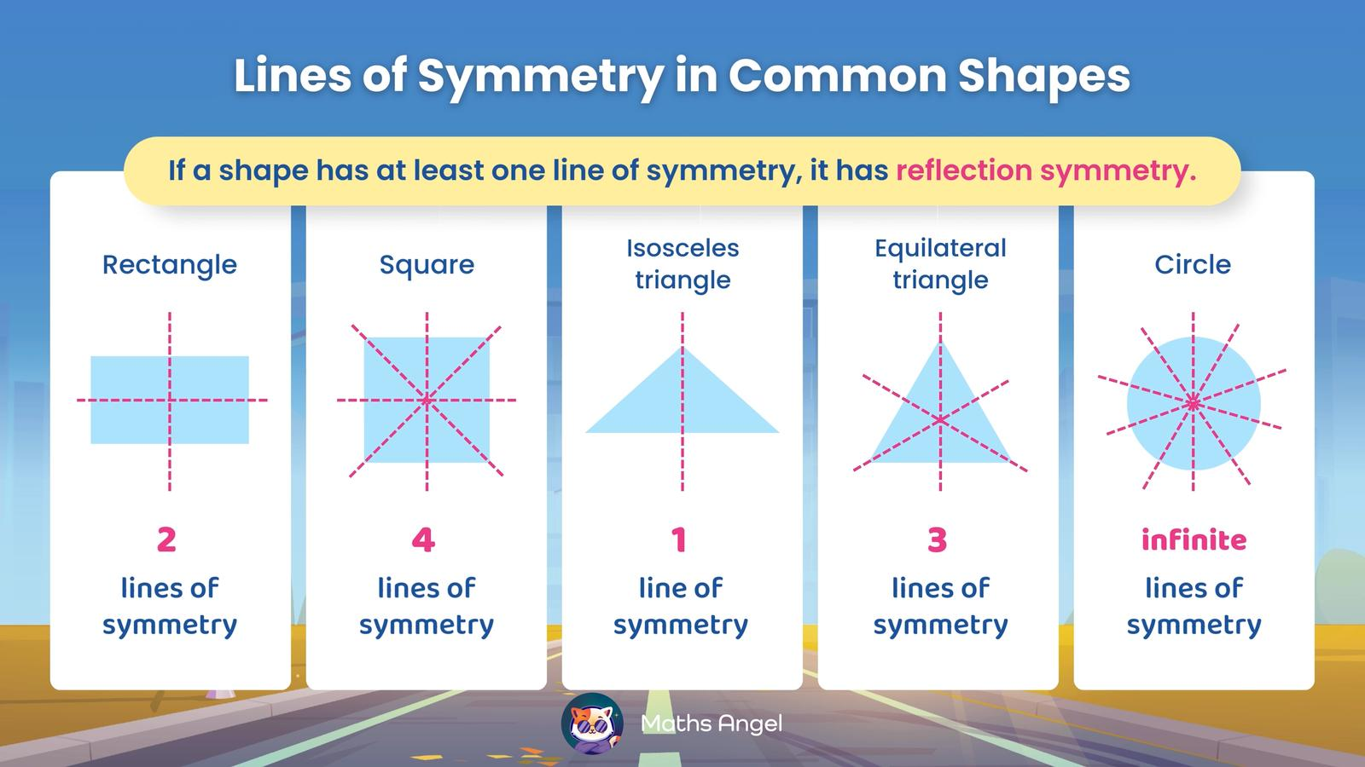
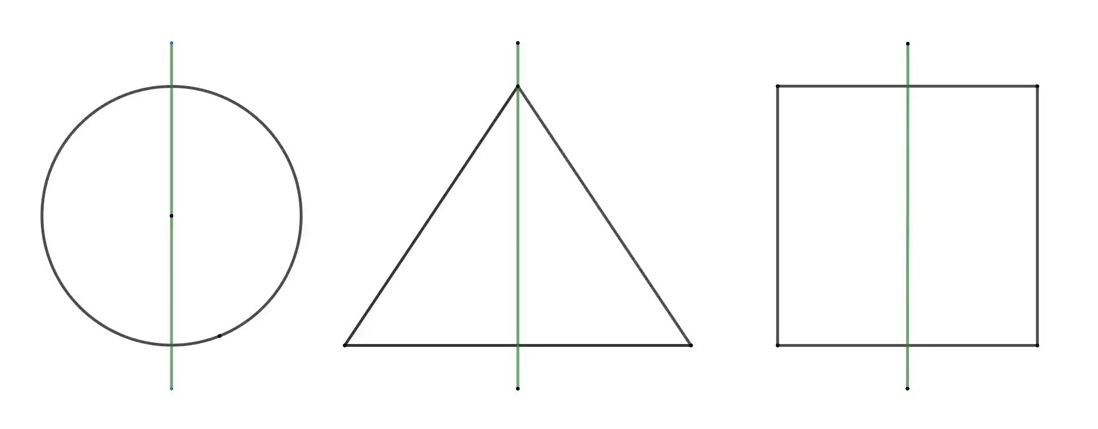
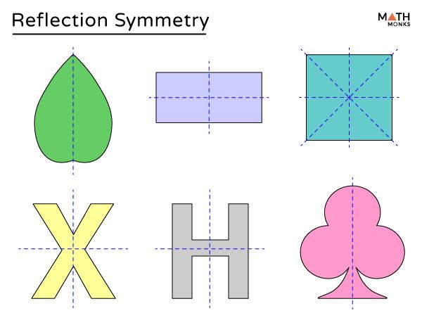

Purpose
# Source: AI Source: Provided by: [Data Path: Persons Table -> ID Column: 1, Name_En Column: Motasem Essam] -> From: [ChatGPT] on [7/25/2026]
Line symmetry is used to:
- Identify mirror-like balance in geometric figures.
- Determine whether a figure can be divided into matching halves.
- Analyze geometric shapes and their properties.
- Understand reflection transformations.
- Identify symmetrical patterns.
- Simplify geometric constructions.
- Create balanced designs.
- Support architecture, engineering, art, and computer graphics.

Fundamental Idea
# Source: AI Source: Provided by: [Data Path: Persons Table -> ID Column: 1, Name_En Column: Motasem Essam] -> From: [ChatGPT] on [7/25/2026]
A figure has line symmetry if there is a line such that reflecting the figure across that line produces the same figure.
For example, a vertical line through the center of a square divides it into two matching halves.
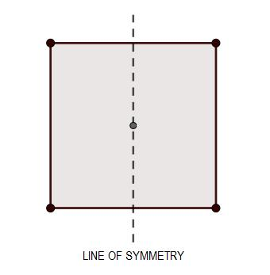
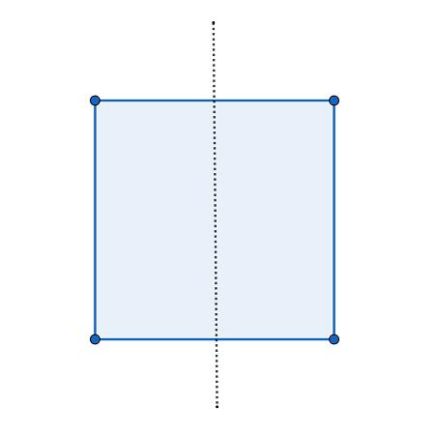
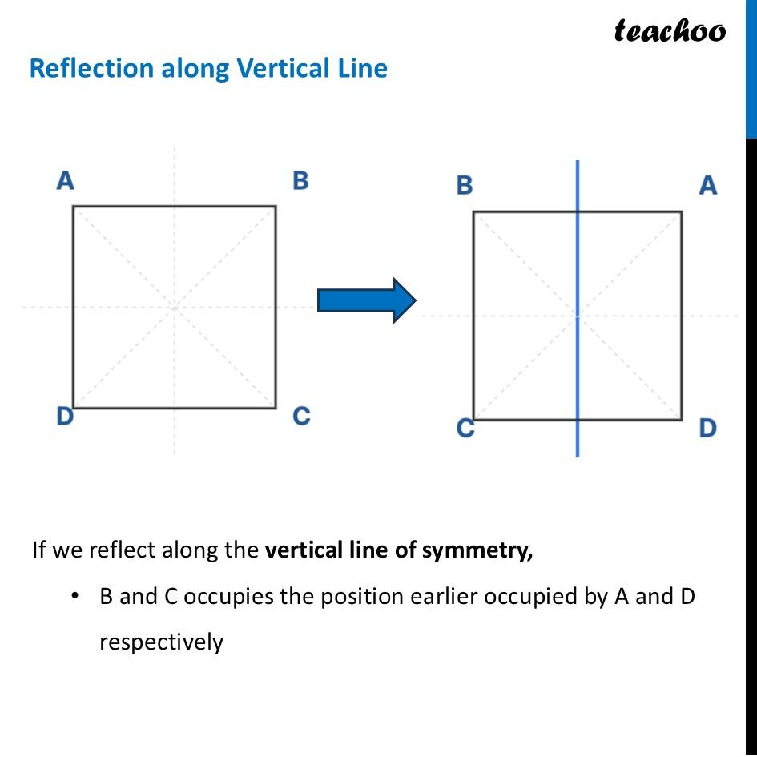
Mathematically:
$$\boxed{\text{Figure}=\text{Reflection of Figure across its symmetry line}}$$

Line of Symmetry
# Source: AI Source: Provided by: [Data Path: Persons Table -> ID Column: 1, Name_En Column: Motasem Essam] -> From: [ChatGPT] on [7/25/2026]
Definition
A line of symmetry is a line that divides a figure into two corresponding mirror-image parts.
The two sides have:
- Equal corresponding lengths.
- Equal corresponding angles.
- Matching shapes.
- Equal distances from the symmetry line.
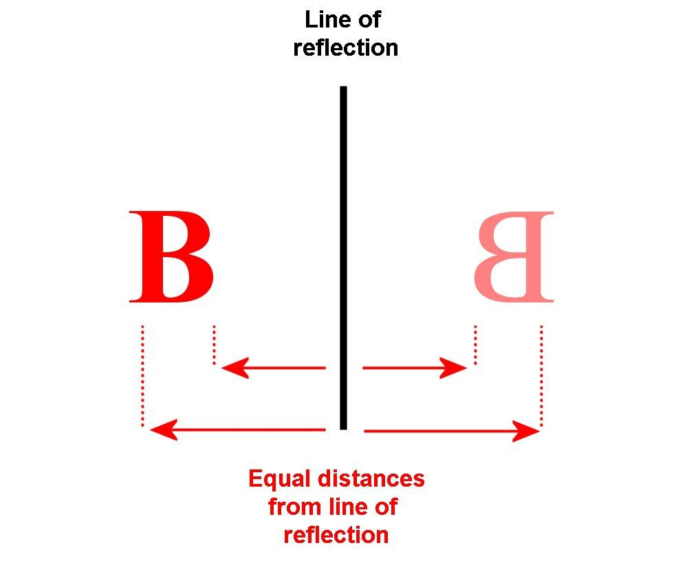
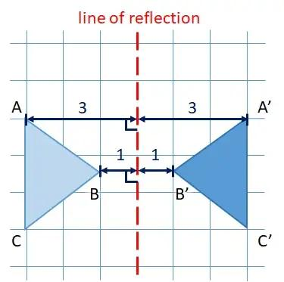
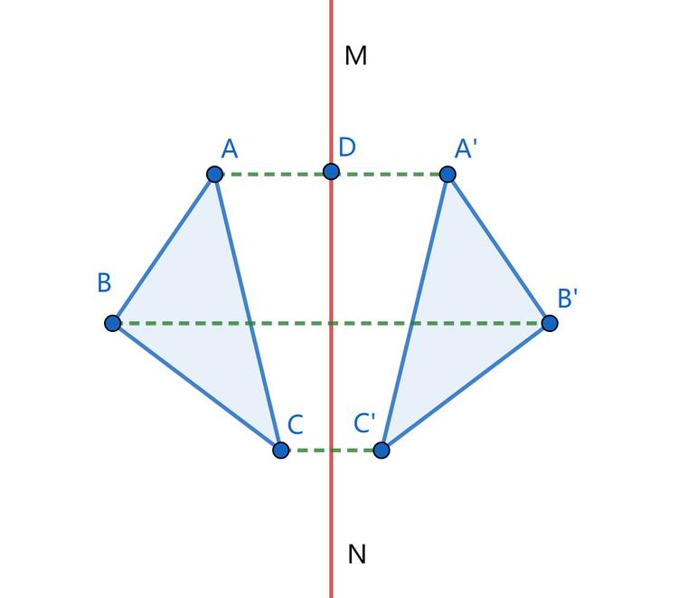
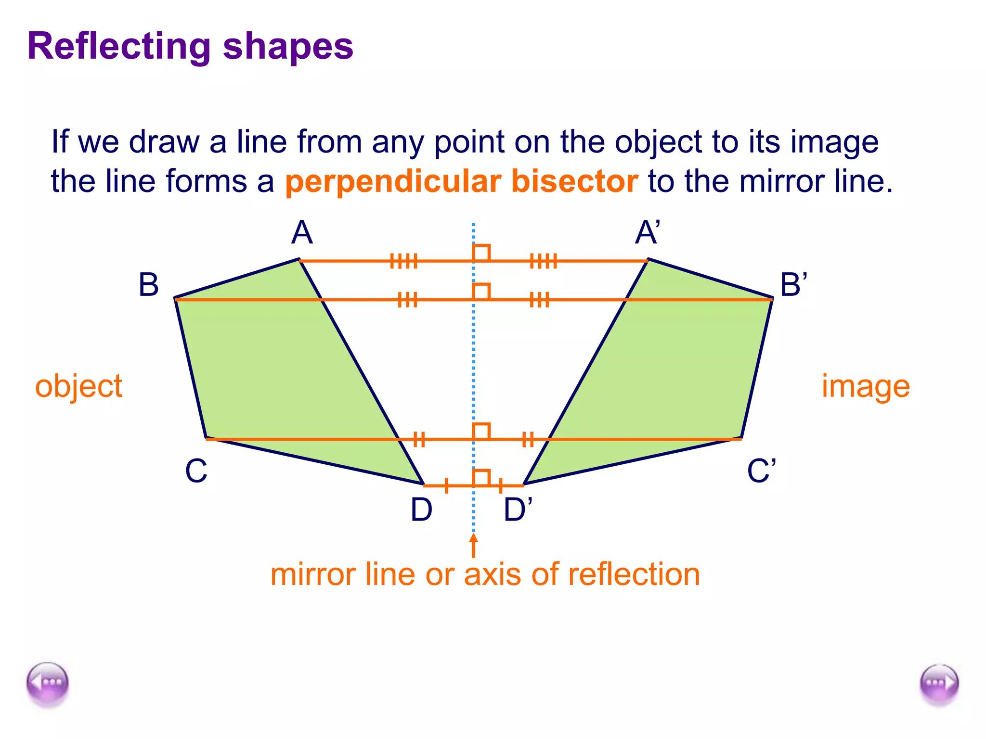
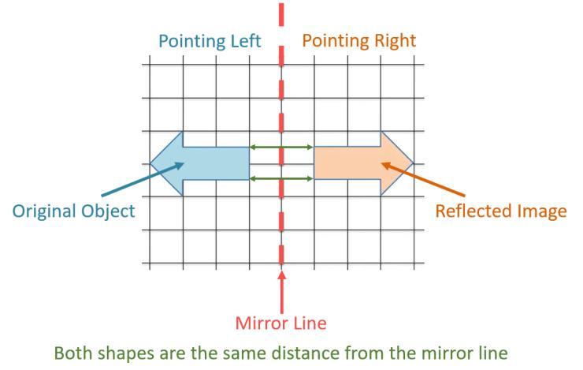

Reflection Across a Line of Symmetry
# Source: AI Source: Provided by: [Data Path: Persons Table -> ID Column: 1, Name_En Column: Motasem Essam] -> From: [ChatGPT] on [7/25/2026]
Line symmetry is directly related to the geometric transformation called reflection.
Suppose point $A$ is reflected across a line to point $A'$.
Then:
$$AA'⊥\text{line of symmetry}$$
and the line of symmetry divides $AA'$ into two equal parts:
$$\boxed{d\left(A,\text{line}\right)=d\left(A',\text{line}\right)}$$
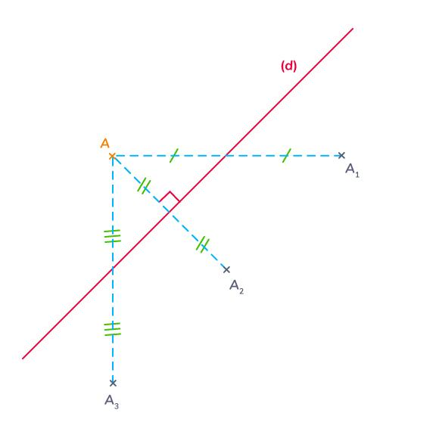
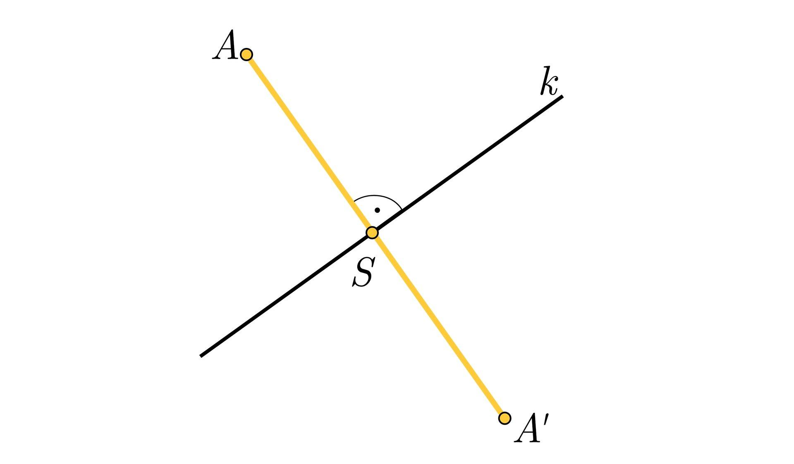
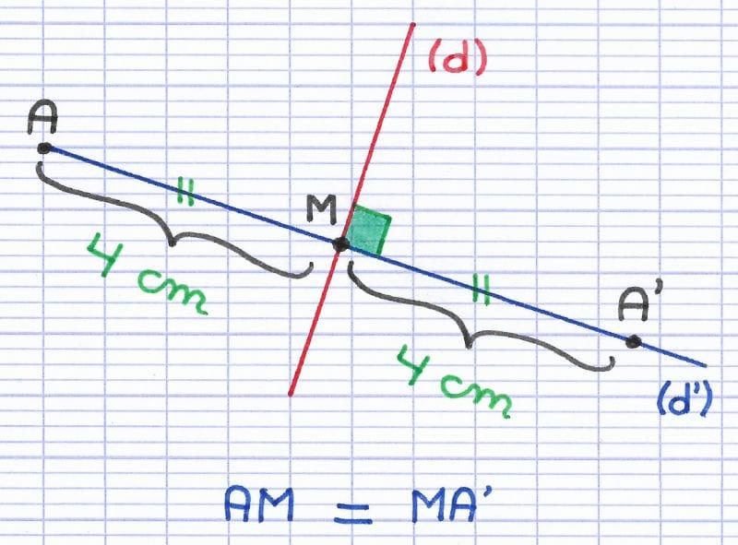
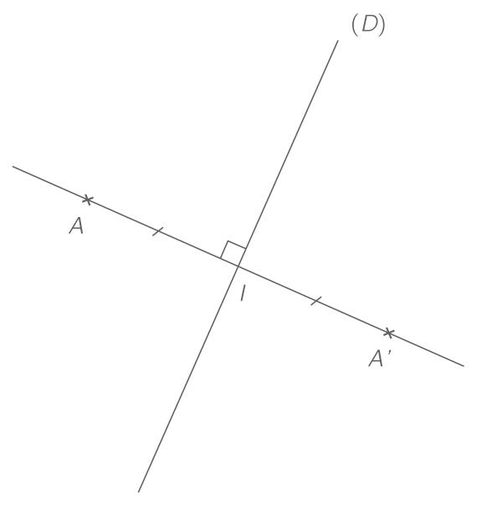
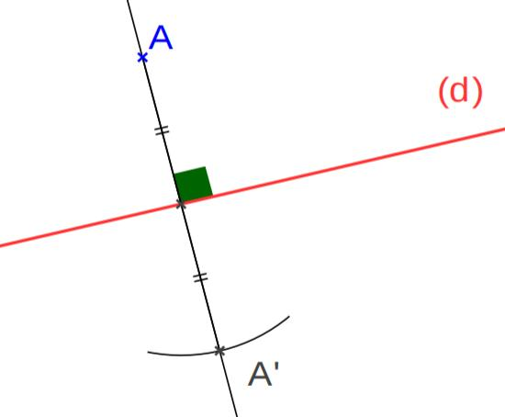

Number of Lines of Symmetry
# Source: AI Source: Provided by: [Data Path: Persons Table -> ID Column: 1, Name_En Column: Motasem Essam] -> From: [ChatGPT] on [7/25/2026]
Different figures have different numbers of lines of symmetry.

Scalene Triangle
# Source: AI Source: Provided by: [Data Path: Persons Table -> ID Column: 1, Name_En Column: Motasem Essam] -> From: [ChatGPT] on [7/25/2026]
A scalene triangle has:
$$\boxed{0}$$
lines of symmetry.
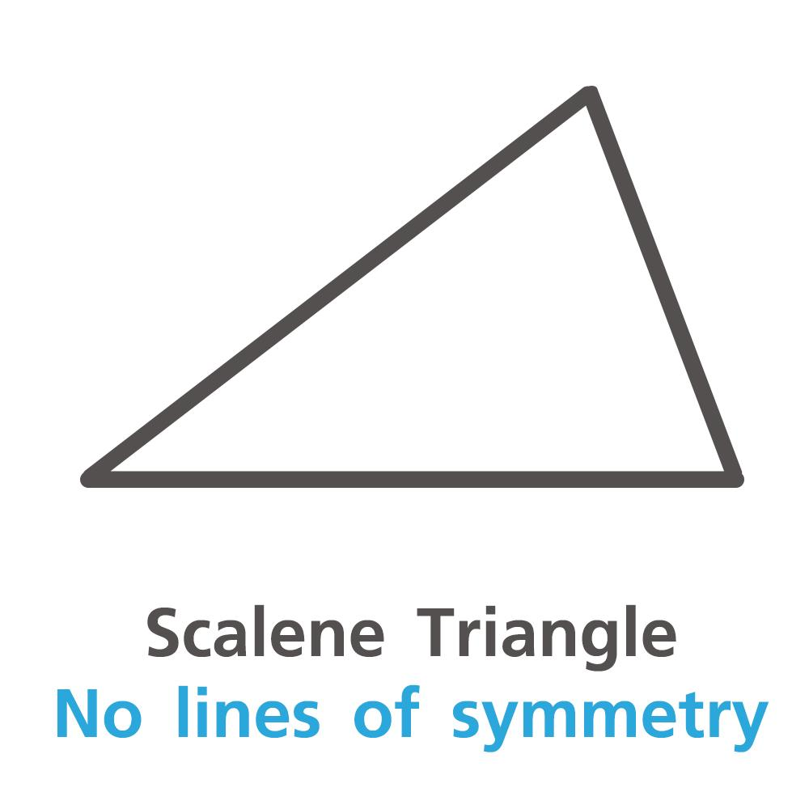
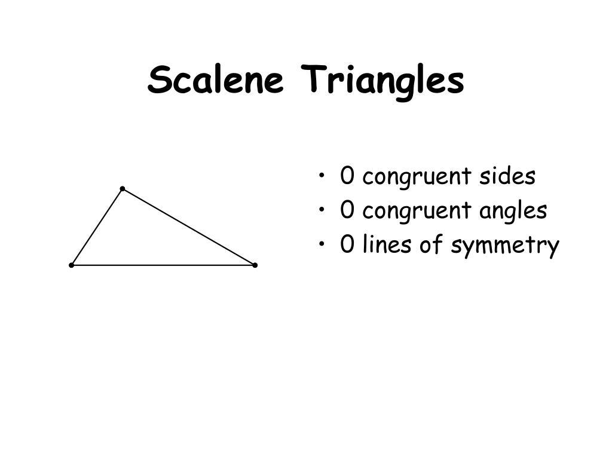
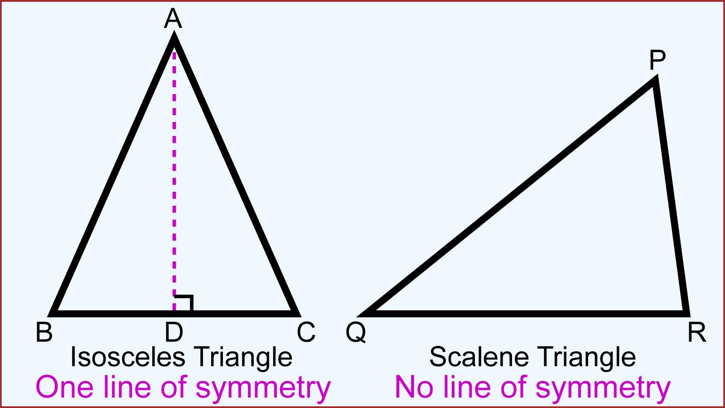
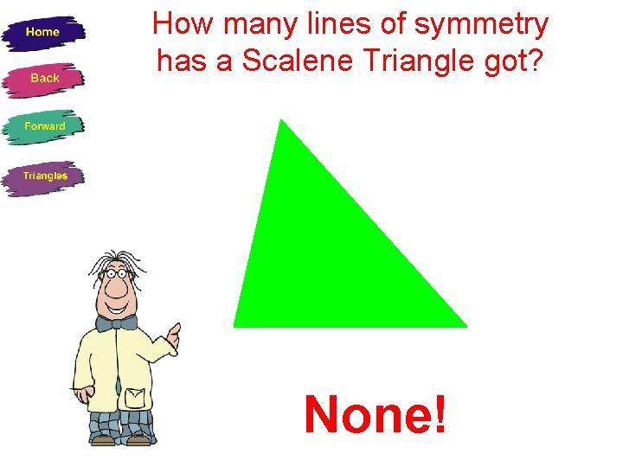

Isosceles Triangle
# Source: AI Source: Provided by: [Data Path: Persons Table -> ID Column: 1, Name_En Column: Motasem Essam] -> From: [ChatGPT] on [7/25/2026]
An isosceles triangle has:
$$\boxed{1}$$
line of symmetry.
The line passes through the vertex between the equal sides and the midpoint of the opposite side.
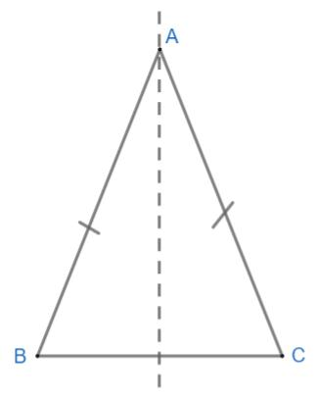
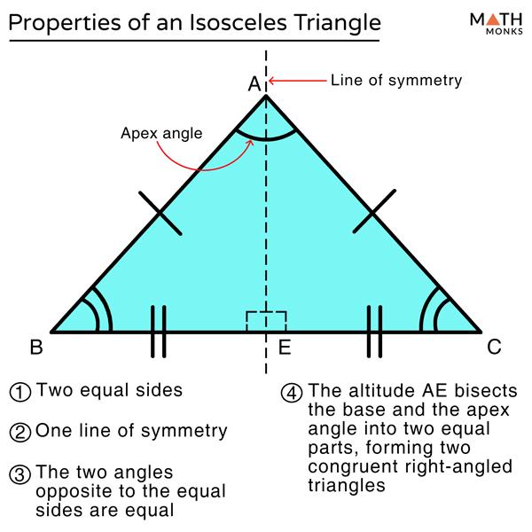
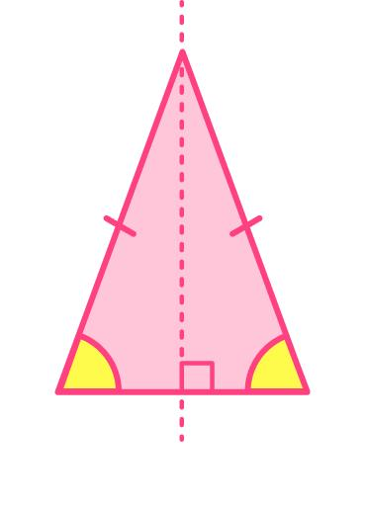
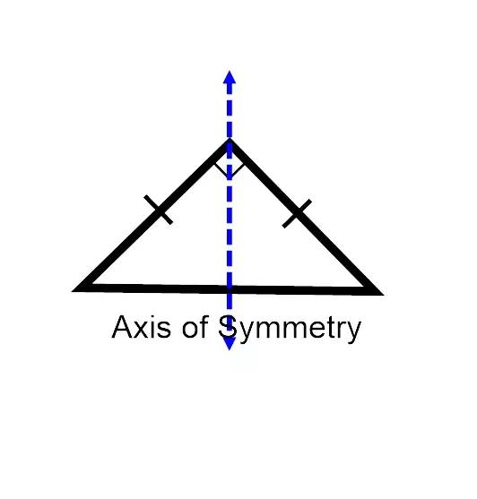
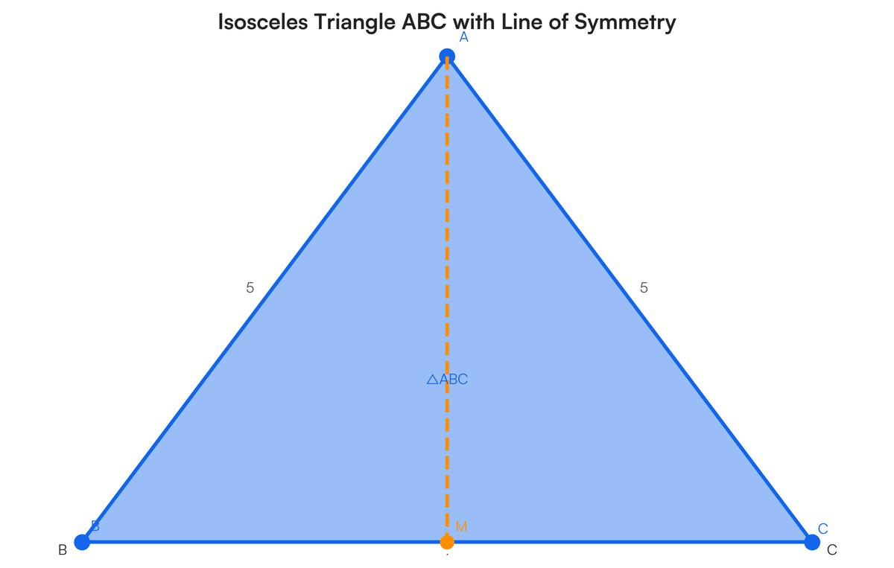

Equilateral Triangle
# Source: AI Source: Provided by: [Data Path: Persons Table -> ID Column: 1, Name_En Column: Motasem Essam] -> From: [ChatGPT] on [7/25/2026]
An equilateral triangle has:
$$\boxed{3}$$
lines of symmetry.
Each line passes through a vertex and the midpoint of the opposite side.
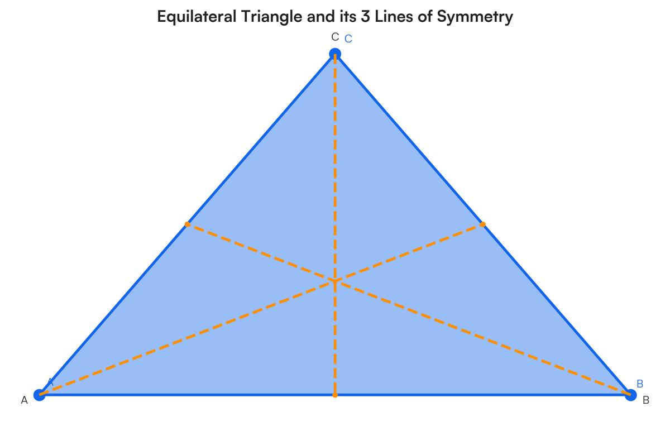
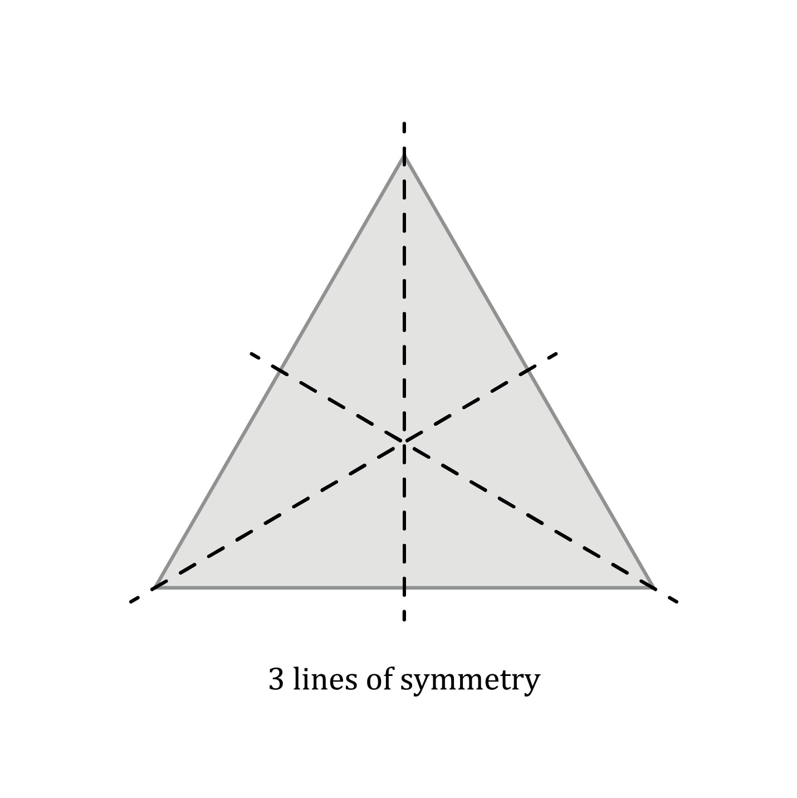
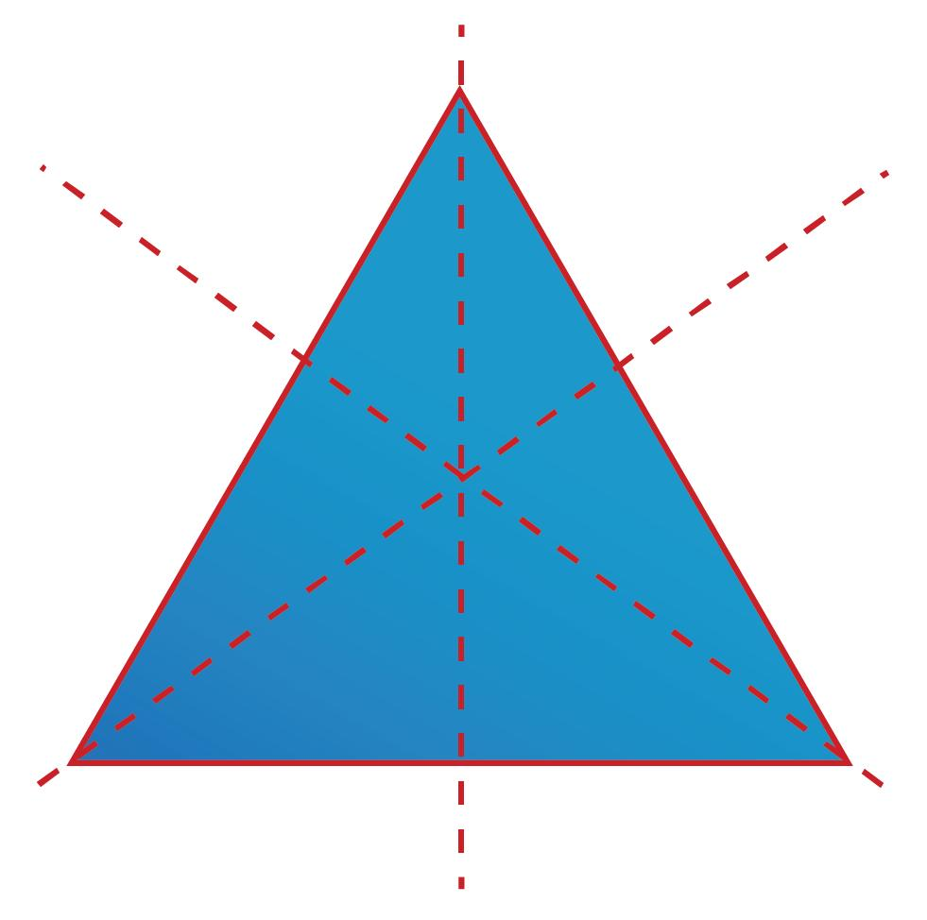
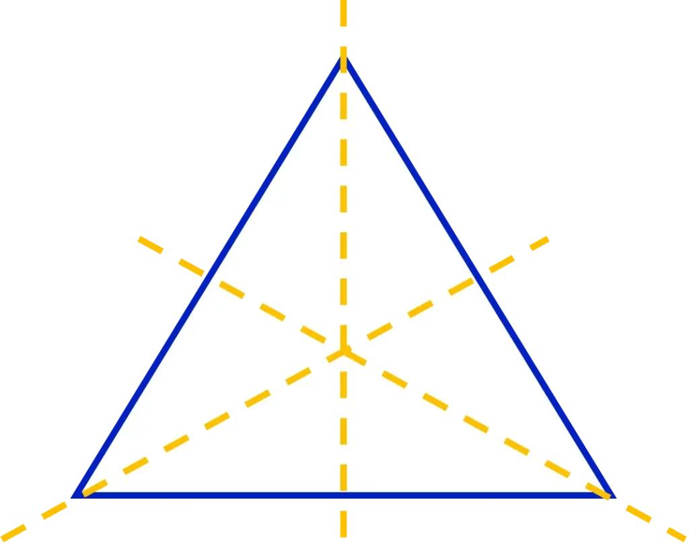

Rectangle
# Source: AI Source: Provided by: [Data Path: Persons Table -> ID Column: 1, Name_En Column: Motasem Essam] -> From: [ChatGPT] on [7/25/2026]
A rectangle that is not a square has:
$$\boxed{2}$$
lines of symmetry.
They pass through the horizontal and vertical centers.
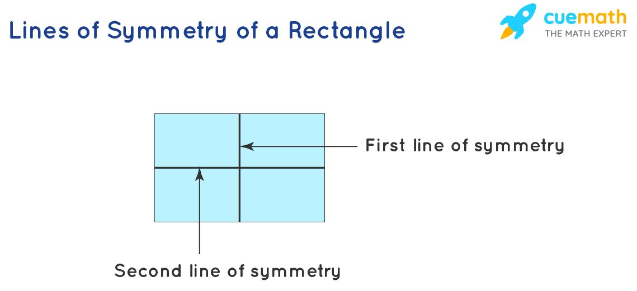
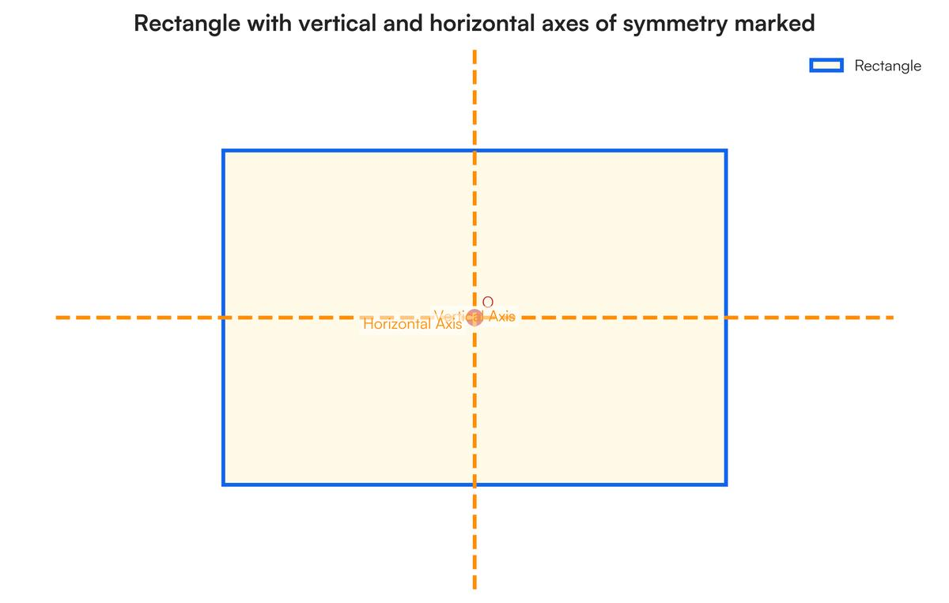
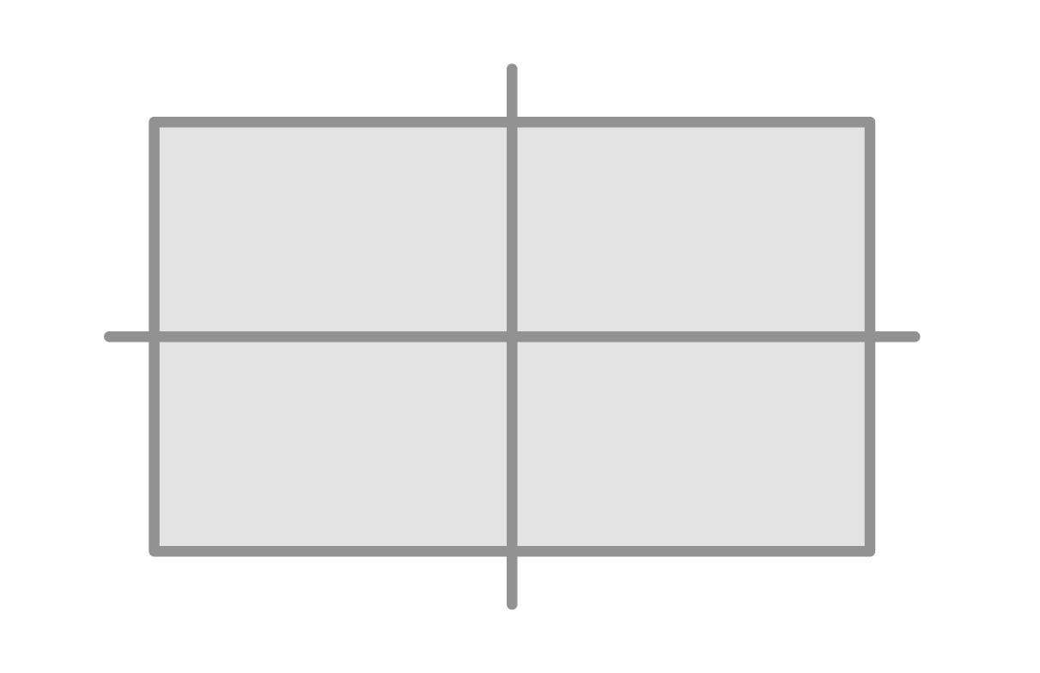
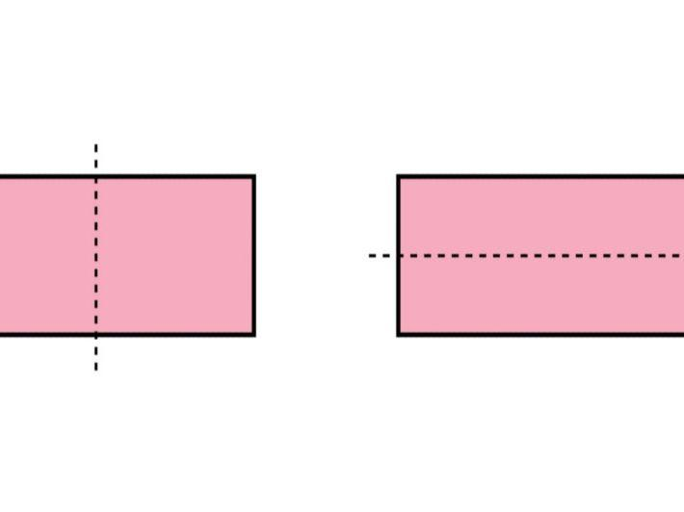
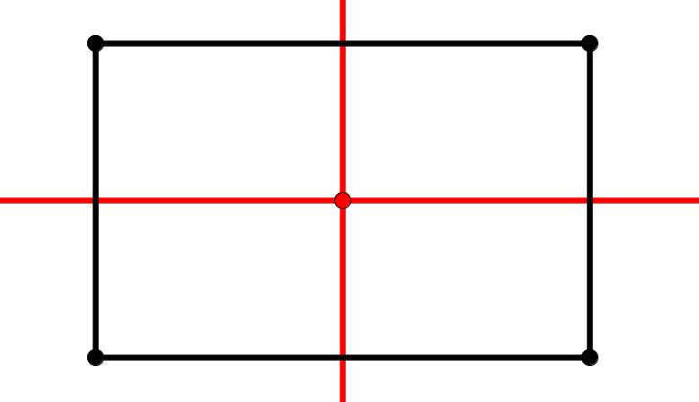

Square
# Source: AI Source: Provided by: [Data Path: Persons Table -> ID Column: 1, Name_En Column: Motasem Essam] -> From: [ChatGPT] on [7/25/2026]
A square has:
$$\boxed{4}$$
lines of symmetry.
They are:
- Vertical.
- Horizontal.
- Main diagonal.
- Other diagonal.
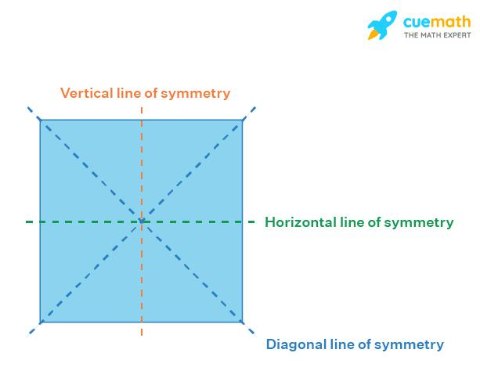
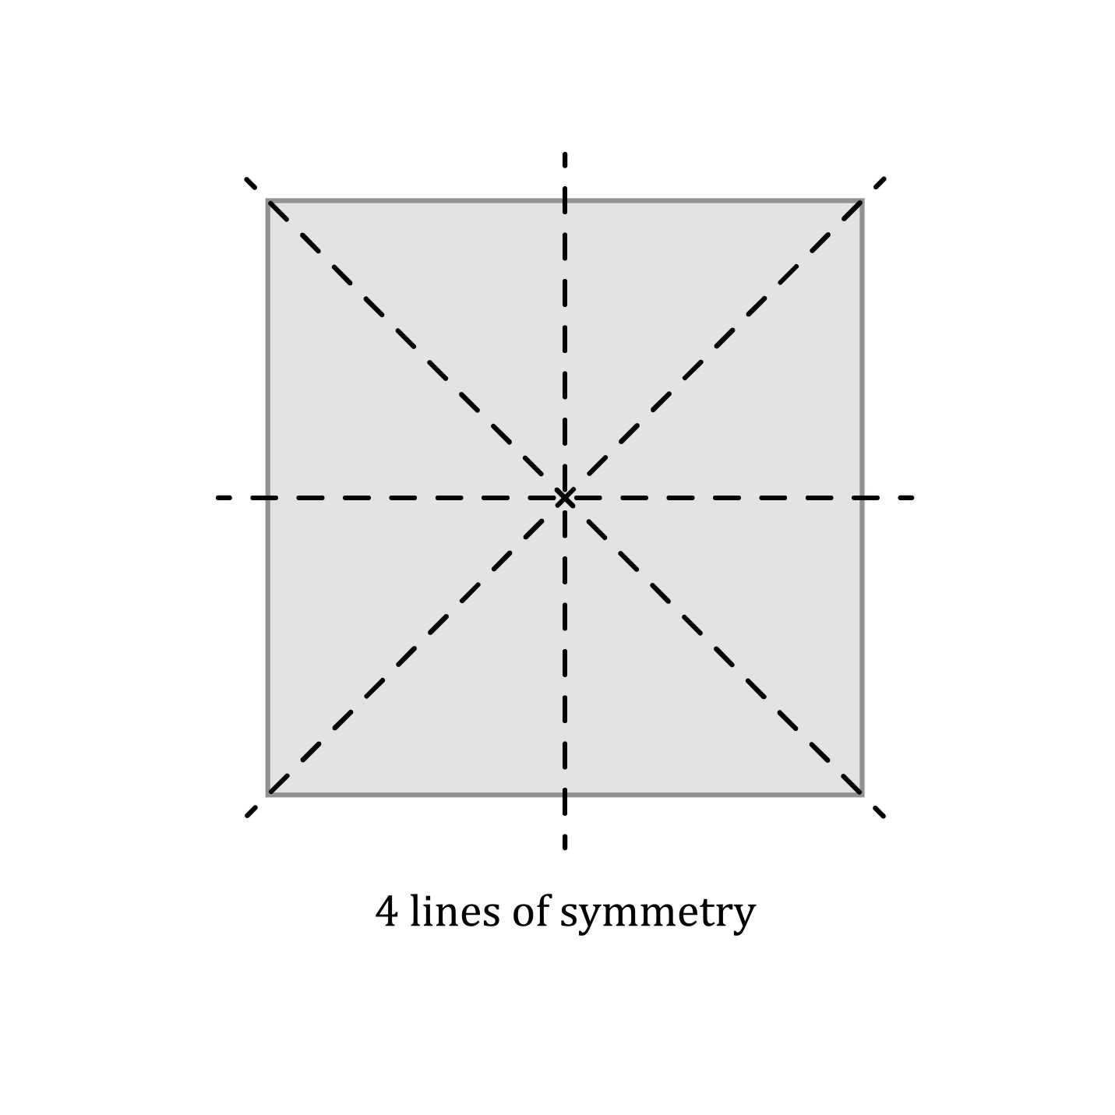
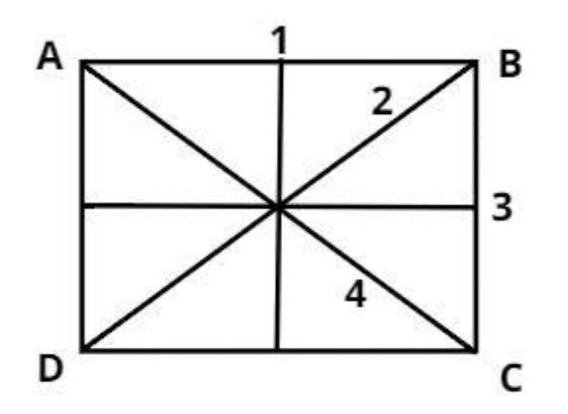
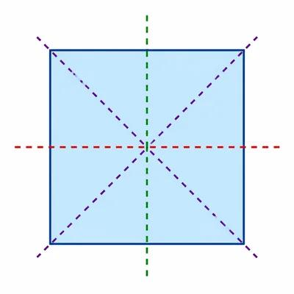
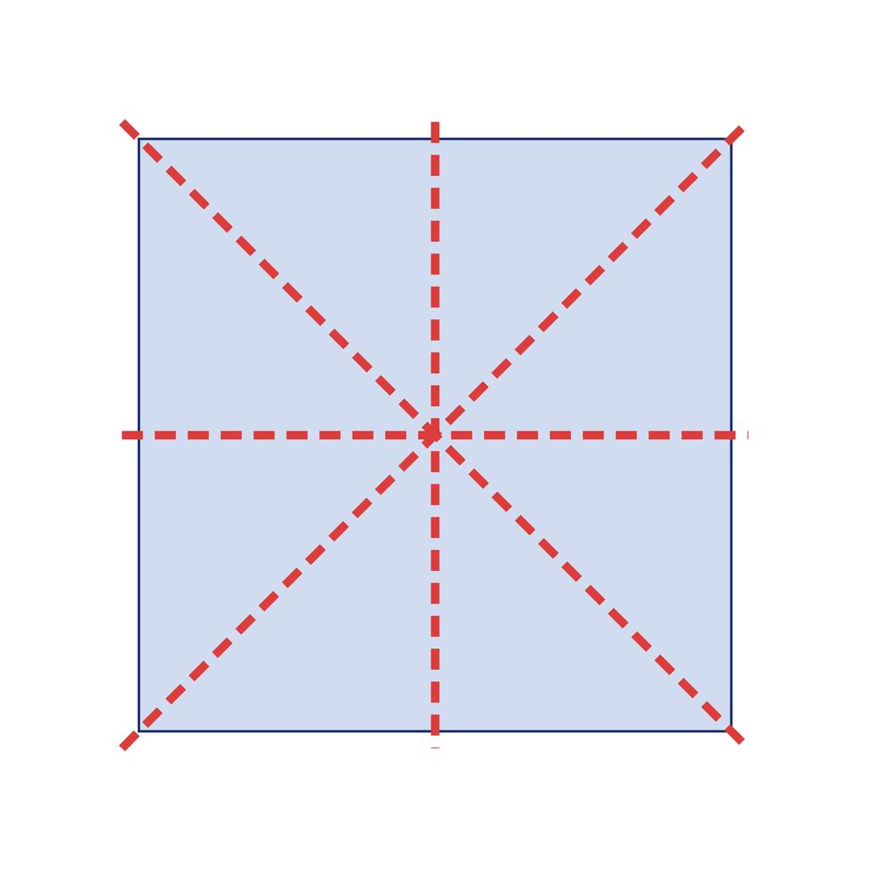

Rhombus
# Source: AI Source: Provided by: [Data Path: Persons Table -> ID Column: 1, Name_En Column: Motasem Essam] -> From: [ChatGPT] on [7/25/2026]
A rhombus generally has:
$$\boxed{2}$$
lines of symmetry.
They are its two diagonals.
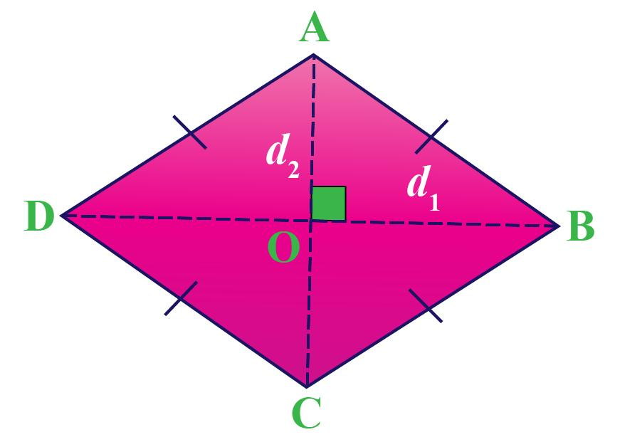
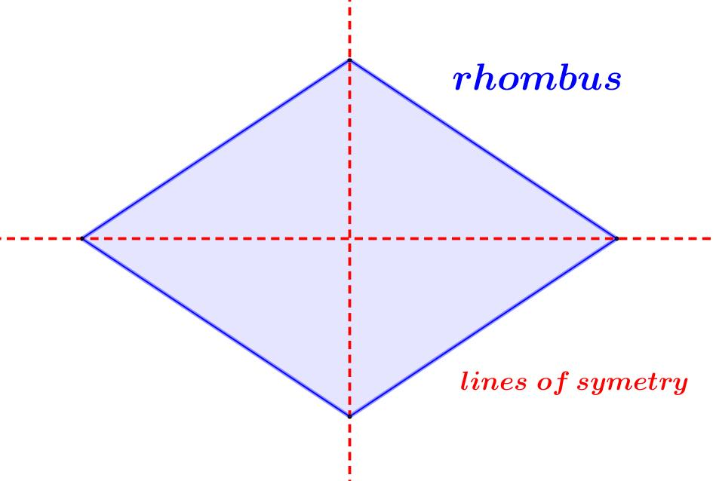
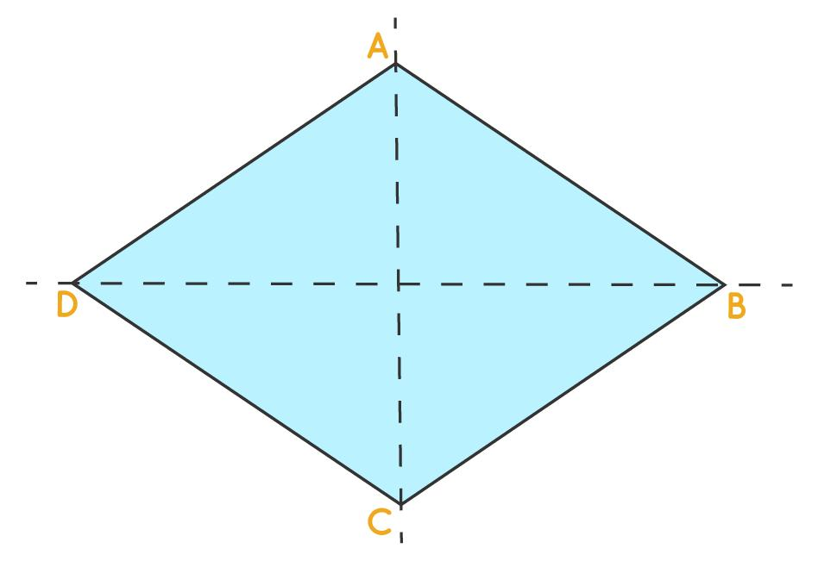
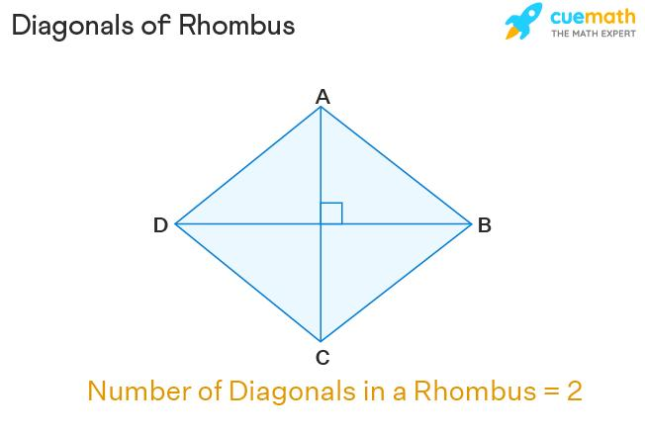

Parallelogram
# Source: AI Source: Provided by: [Data Path: Persons Table -> ID Column: 1, Name_En Column: Motasem Essam] -> From: [ChatGPT] on [7/25/2026]
A general parallelogram has:
$$\boxed{0}$$
lines of symmetry.
However, special parallelograms such as rectangles and rhombi have line symmetry.
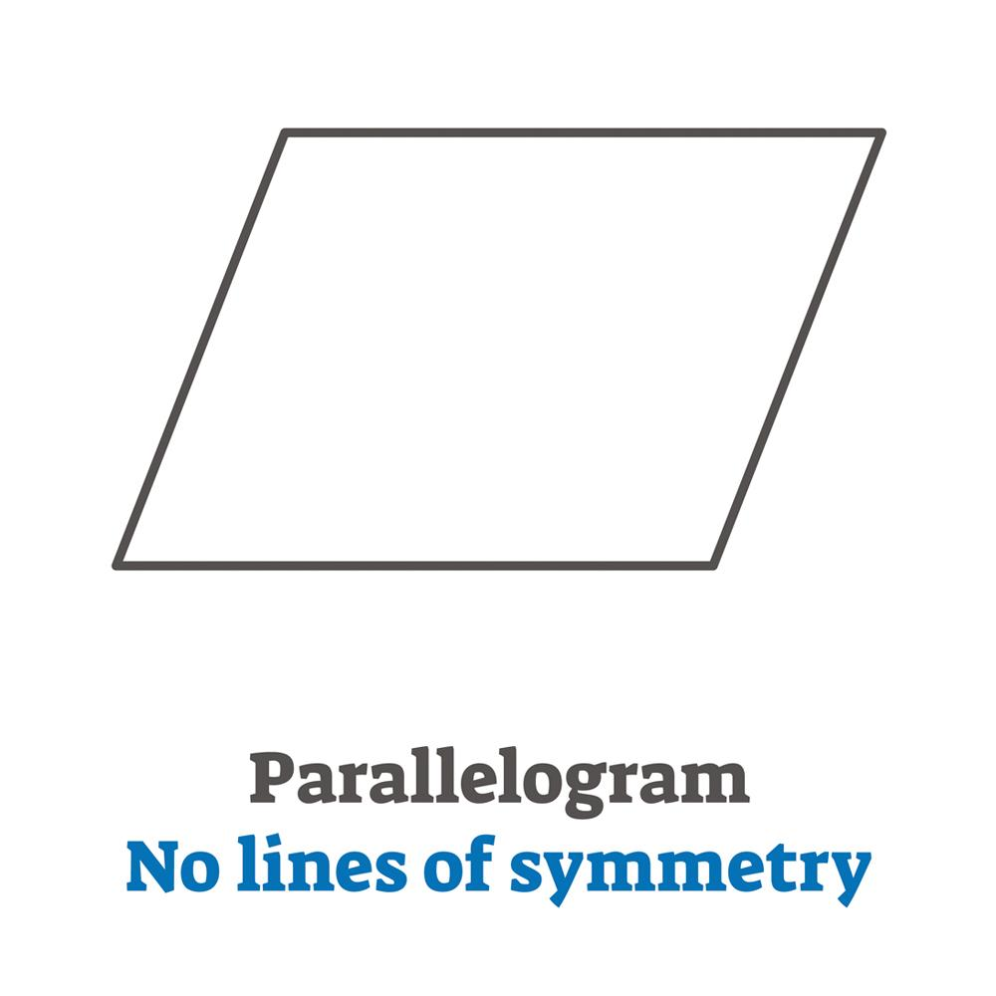
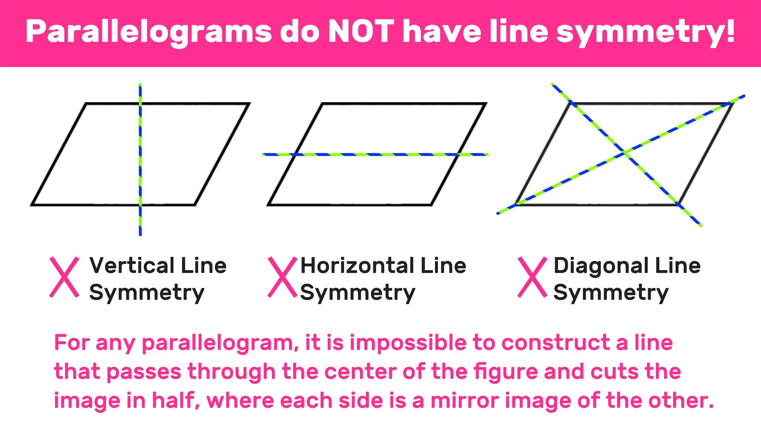
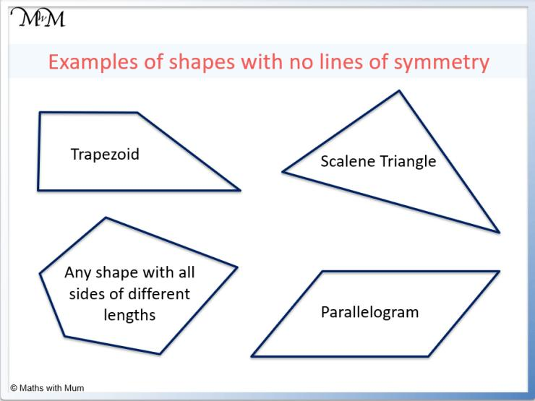

Circle
# Source: AI Source: Provided by: [Data Path: Persons Table -> ID Column: 1, Name_En Column: Motasem Essam] -> From: [ChatGPT] on [7/25/2026]
A circle has infinitely many lines of symmetry.
Every diameter is a line of symmetry.
$$\boxed{∞}$$
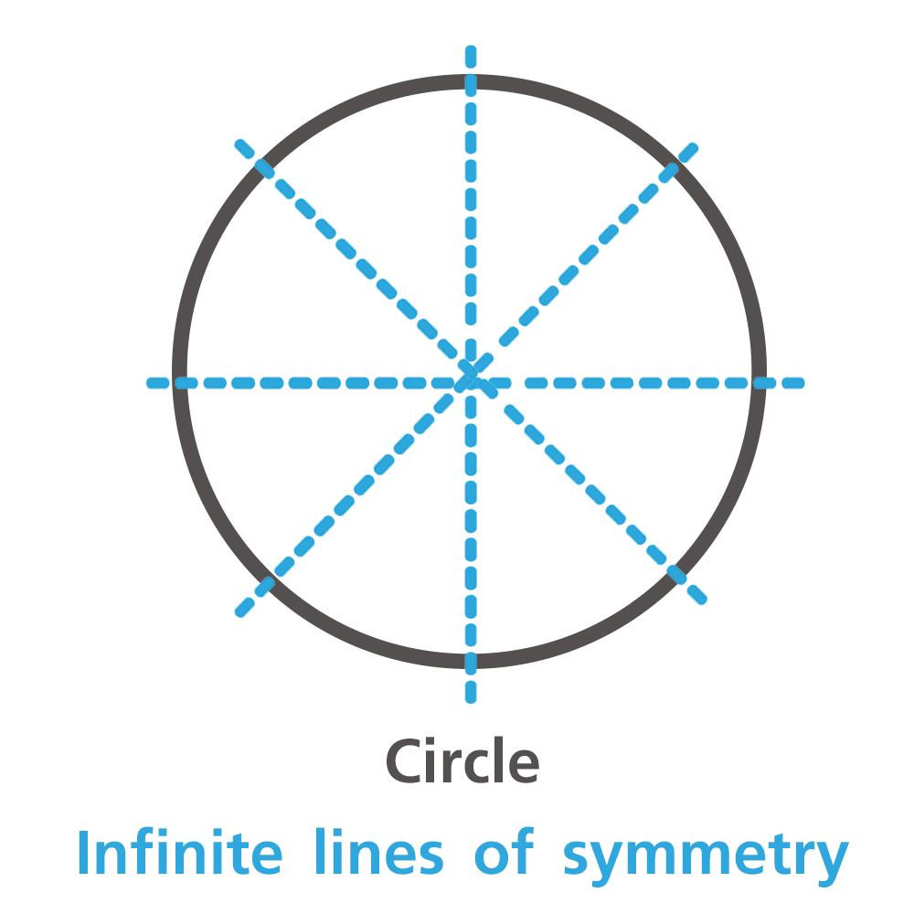
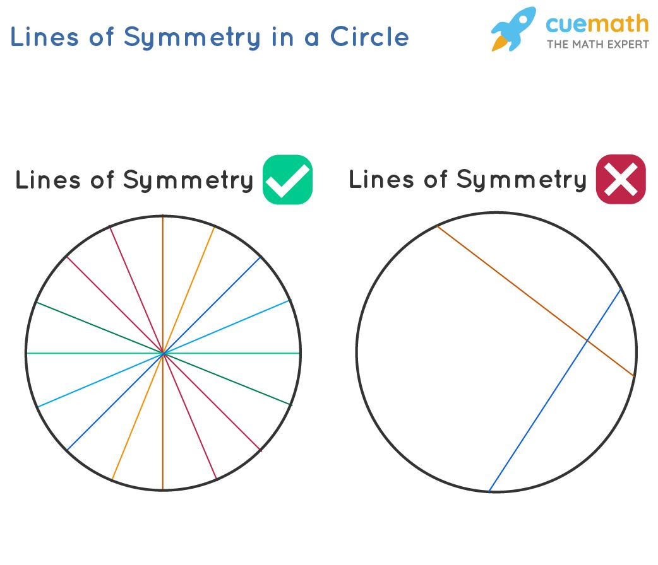
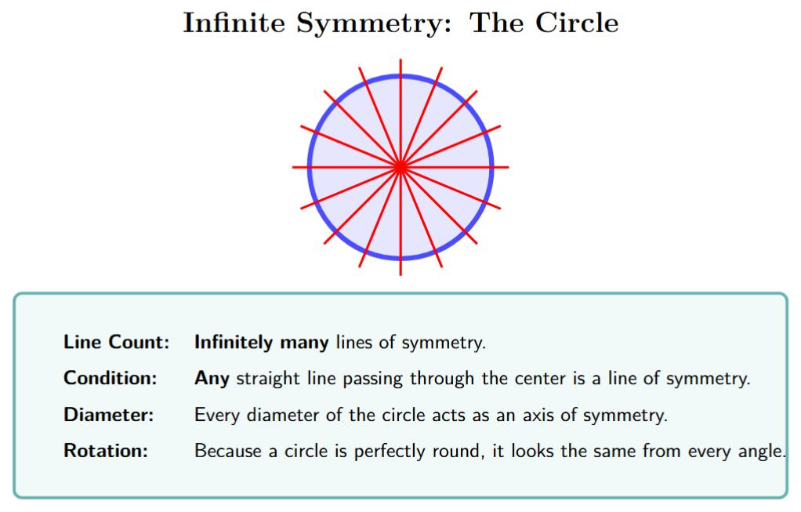
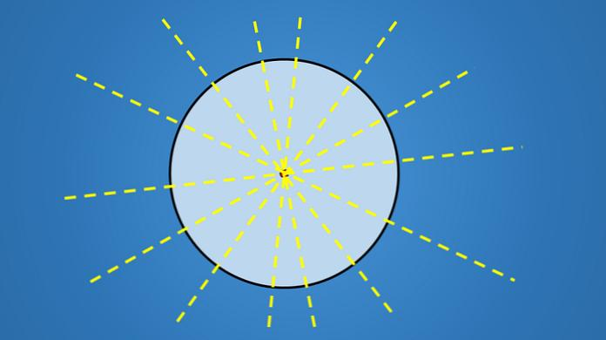
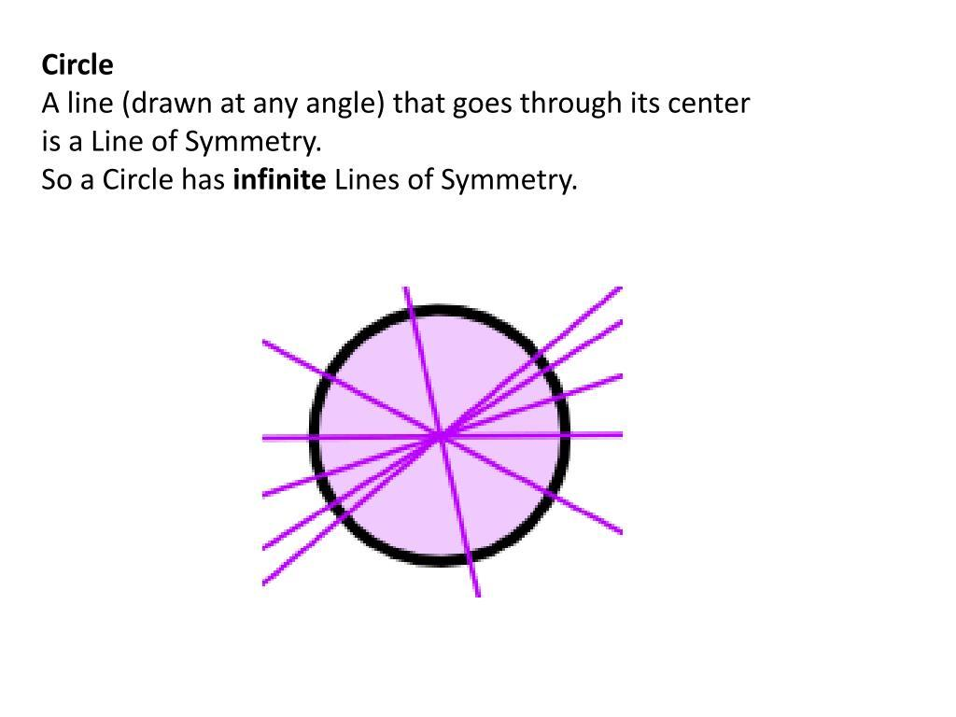

Regular Polygons
# Source: AI Source: Provided by: [Data Path: Persons Table -> ID Column: 1, Name_En Column: Motasem Essam] -> From: [ChatGPT] on [7/25/2026]
A regular polygon with $n$ sides has exactly:
$$\boxed{n}$$
lines of symmetry.
Examples:
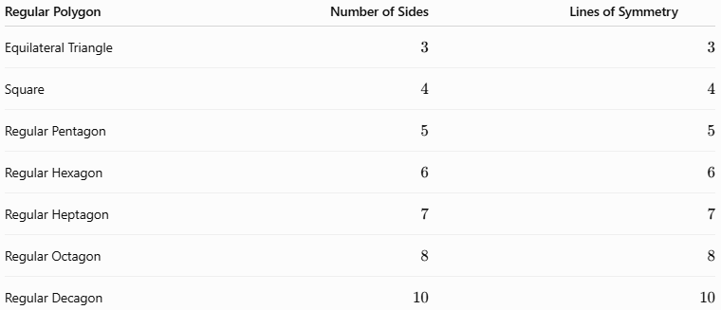
Regular Polygon | Number of Sides | Lines of Symmetry
Equilateral Triangle | $$3$$ | $$3$$
Square | $$4$$ | $$4$$
Regular Pentagon | $$5$$ | $$5$$
Regular Hexagon | $$6$$ | $$6$$
Regular Heptagon | $$7$$ | $$7$$
Regular Octagon | $$8$$ | $$8$$
Regular Decagon | $$10$$ | $$10$$
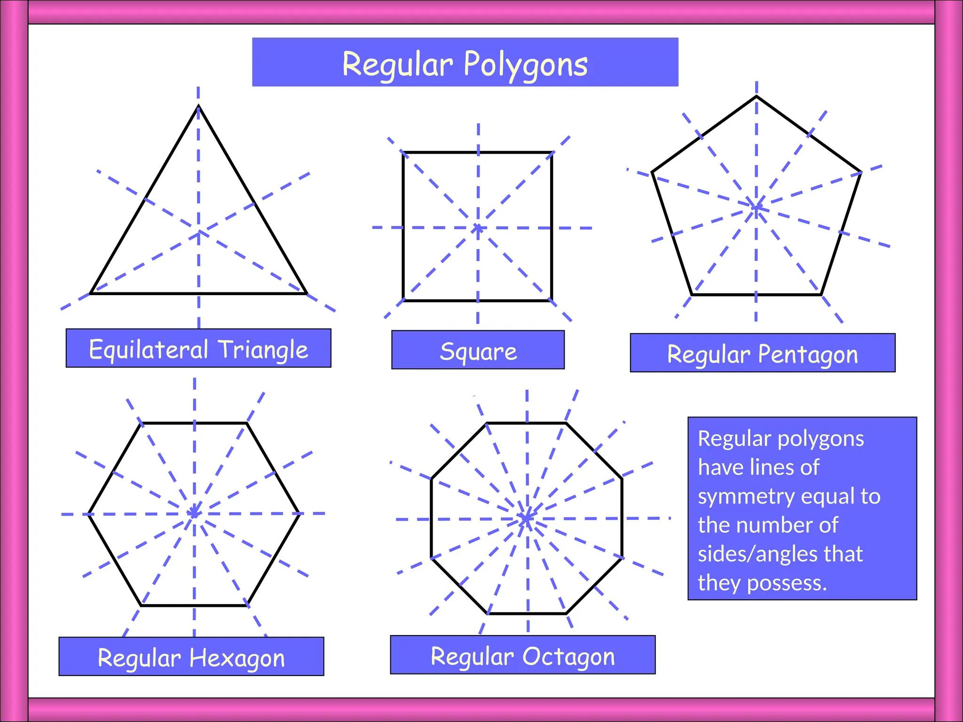
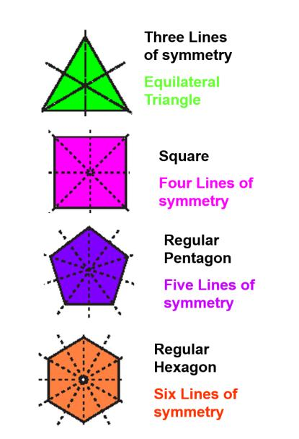
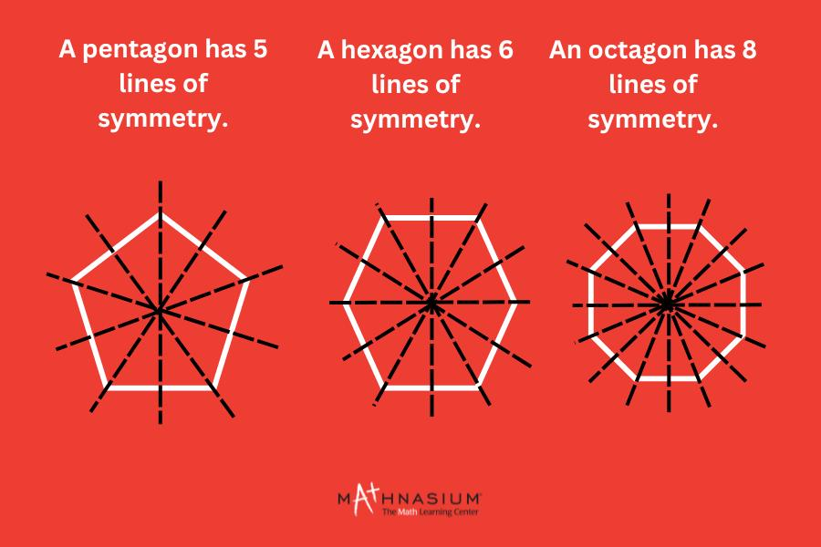
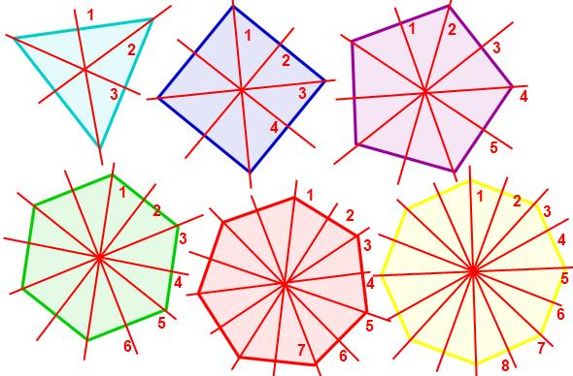
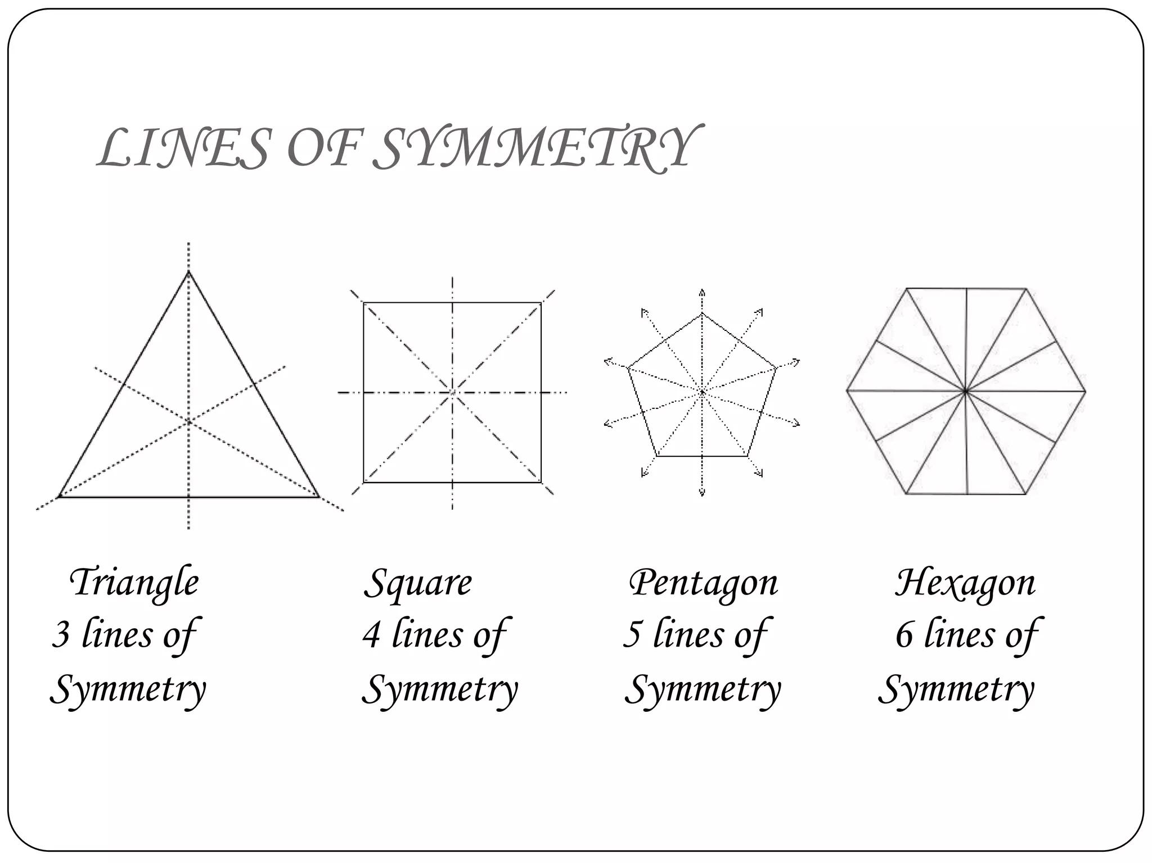

Properties of Line Symmetry
# Source: AI Source: Provided by: [Data Path: Persons Table -> ID Column: 1, Name_En Column: Motasem Essam] -> From: [ChatGPT] on [7/25/2026]
A figure with line symmetry has several important properties.
1. Mirror Images
The two sides of the figure are mirror images of each other.
2. Equal Distances
Corresponding points are equally distant from the line of symmetry.
$$d\left(A,L\right)=d\left(A',L\right)$$
3. Perpendicular Connection
The segment connecting corresponding points is perpendicular to the line of symmetry.
$$AA'⊥L$$
4. Equal Corresponding Parts
Corresponding sides and angles are equal.
5. Congruence
Reflection preserves size and shape.
Therefore, the original figure and its reflected image are congruent:
$$\boxed{\text{Original}≅\text{Reflected Image}}$$

Line Symmetry in Coordinate Geometry
# Source: AI Source: Provided by: [Data Path: Persons Table -> ID Column: 1, Name_En Column: Motasem Essam] -> From: [ChatGPT] on [7/25/2026]
Line symmetry can be represented mathematically using coordinates.

Symmetry About the $x$-Axis
# Source: AI Source: Provided by: [Data Path: Persons Table -> ID Column: 1, Name_En Column: Motasem Essam] -> From: [ChatGPT] on [7/25/2026]
Reflection across the $x$-axis:
$$\boxed{\left(x,y\right)→\left(x,-y\right)}$$
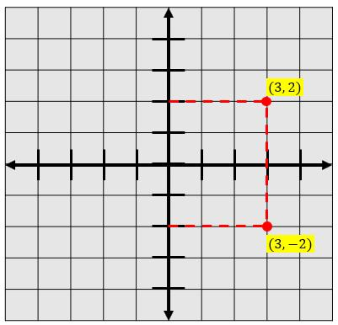
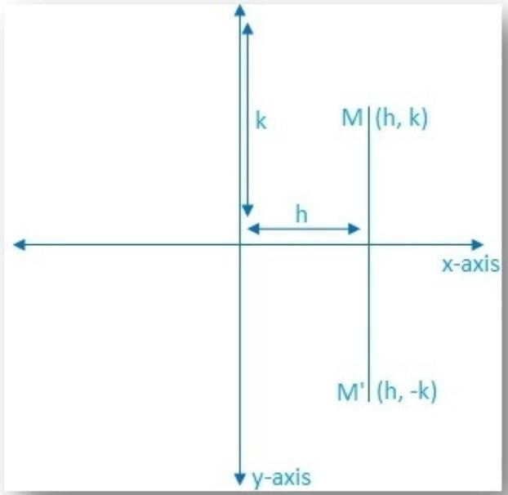
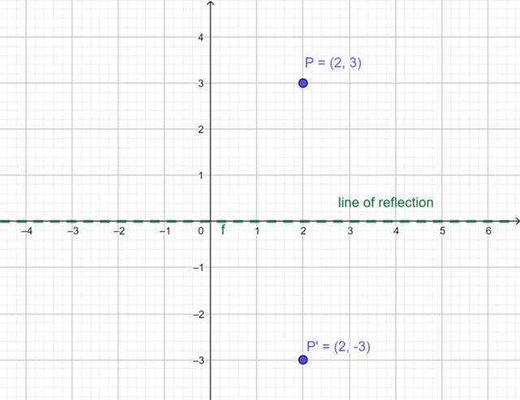
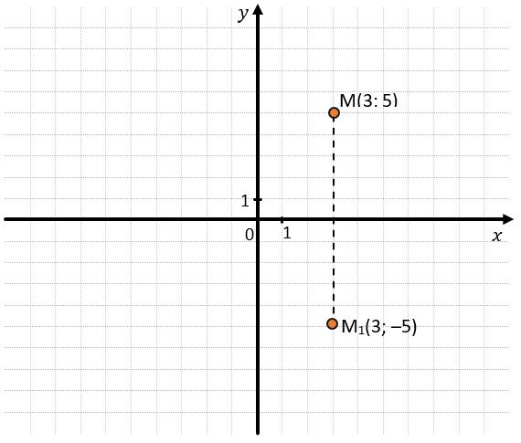

Symmetry About the $y$-Axis
# Source: AI Source: Provided by: [Data Path: Persons Table -> ID Column: 1, Name_En Column: Motasem Essam] -> From: [ChatGPT] on [7/25/2026]
Reflection across the $y$-axis:
$$\boxed{\left(x,y\right)→\left(-x,y\right)}$$
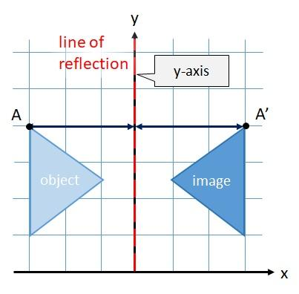
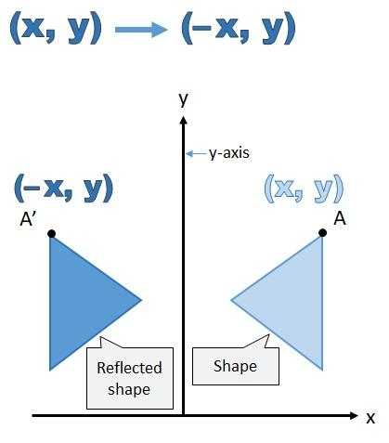
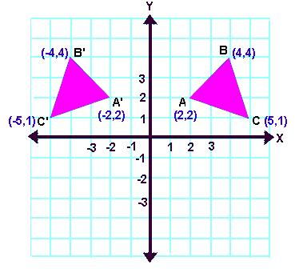
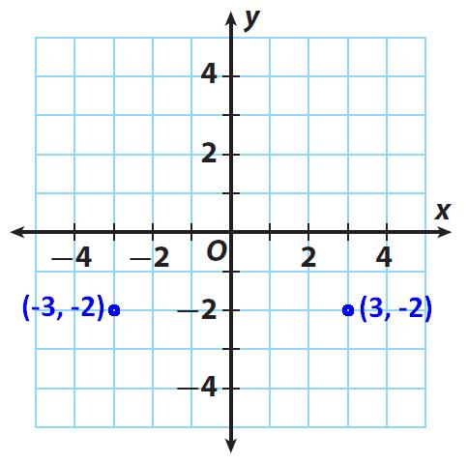
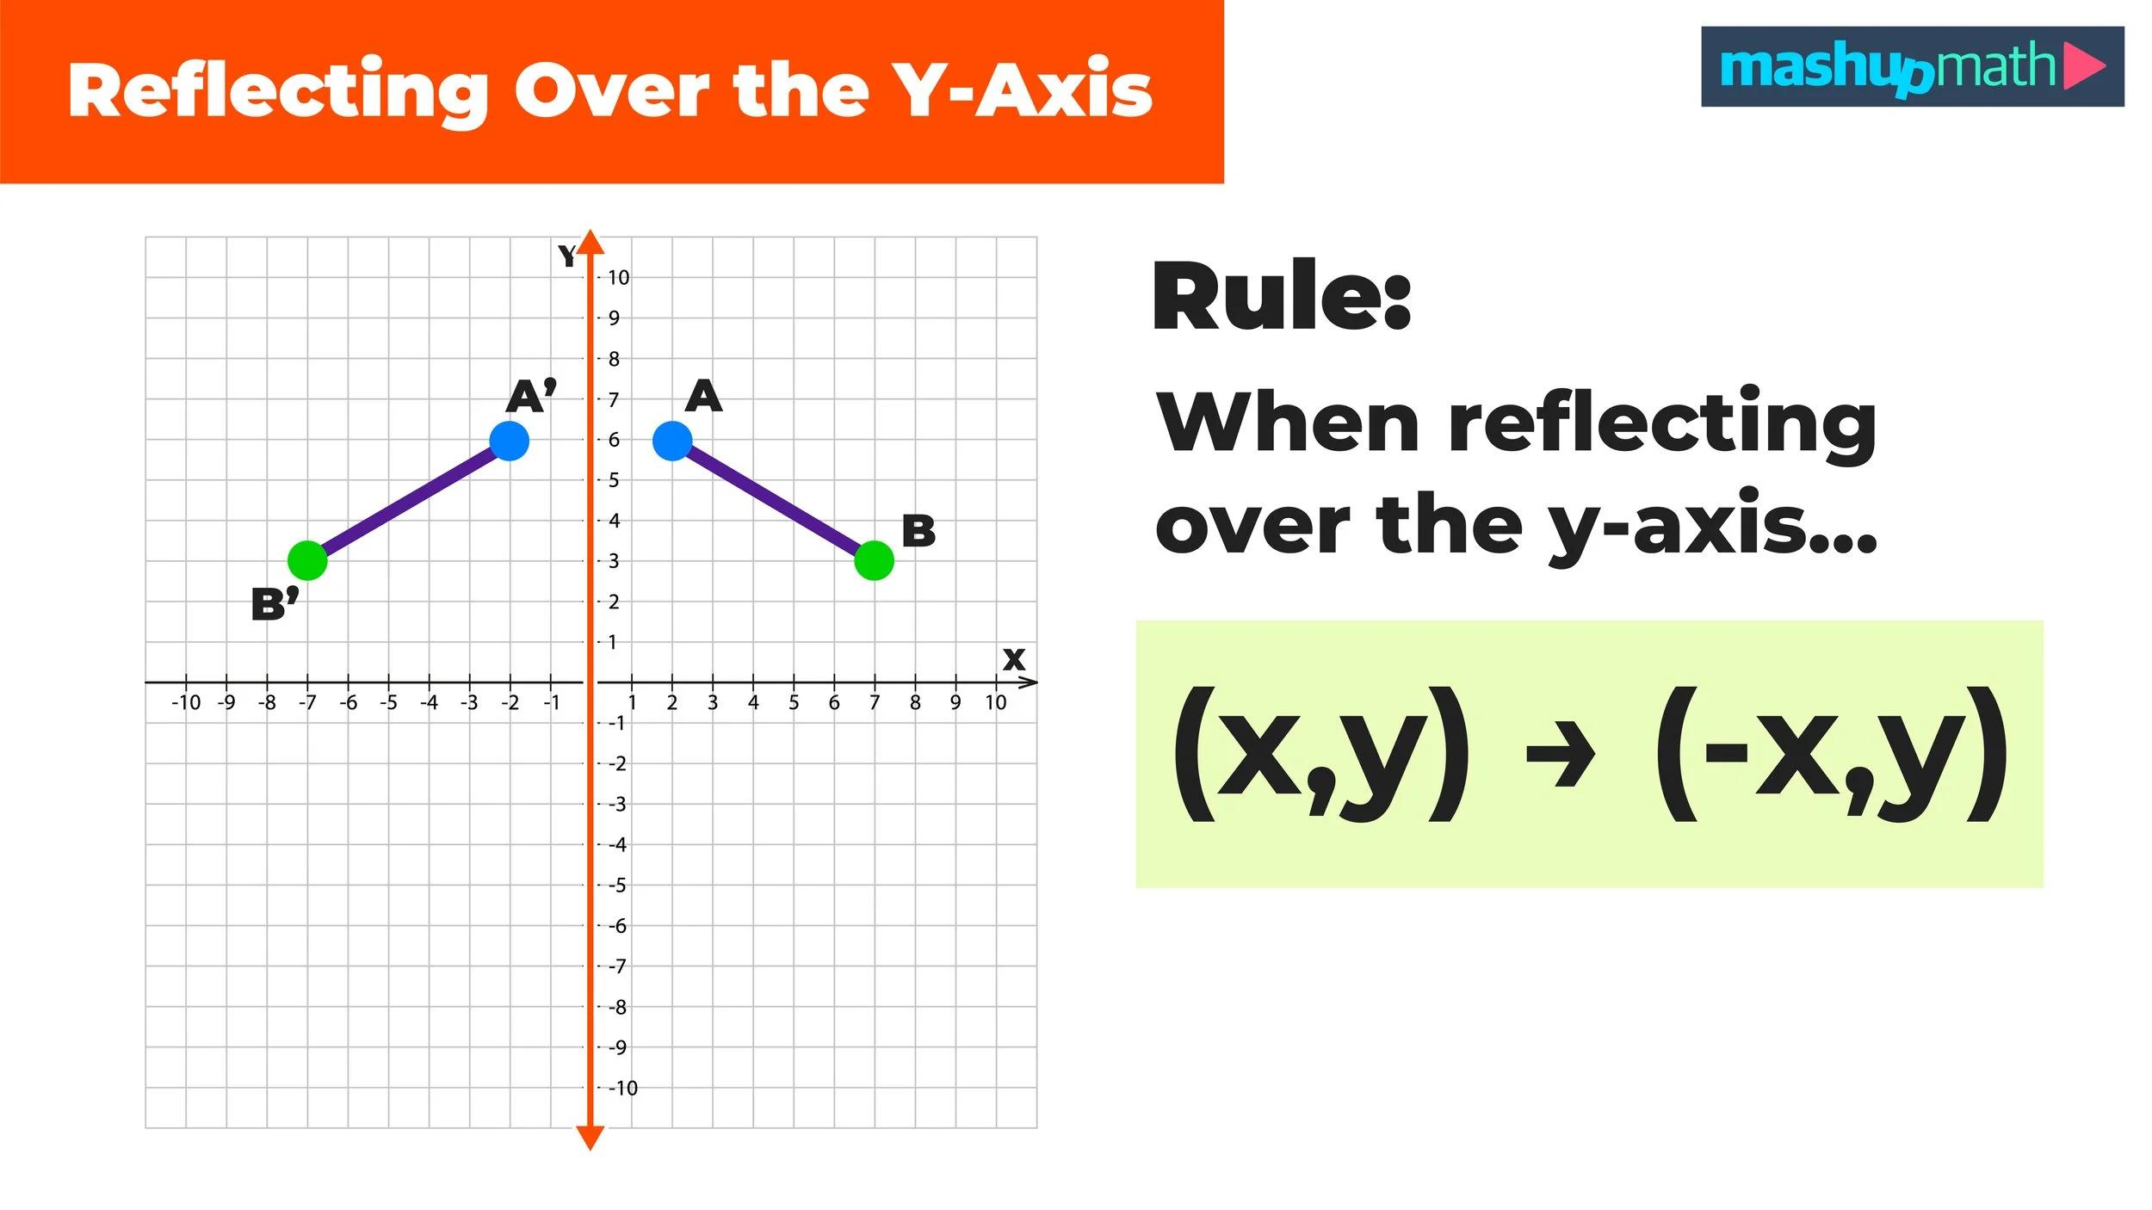

Symmetry About the Line $y=x$
# Source: AI Source: Provided by: [Data Path: Persons Table -> ID Column: 1, Name_En Column: Motasem Essam] -> From: [ChatGPT] on [7/25/2026]
Reflection across:
$$y=x$$
is represented by:
$$\boxed{\left(x,y\right)→\left(y,x\right)}$$
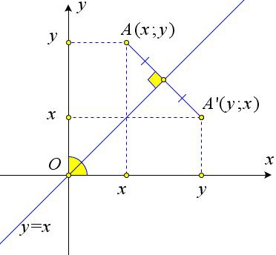
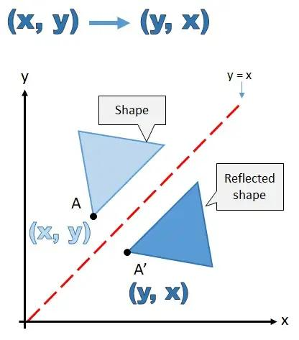
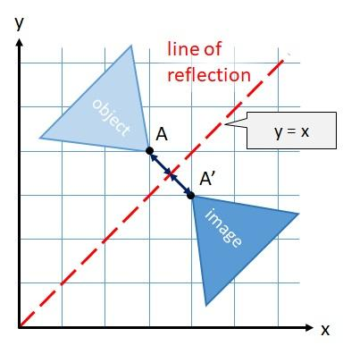
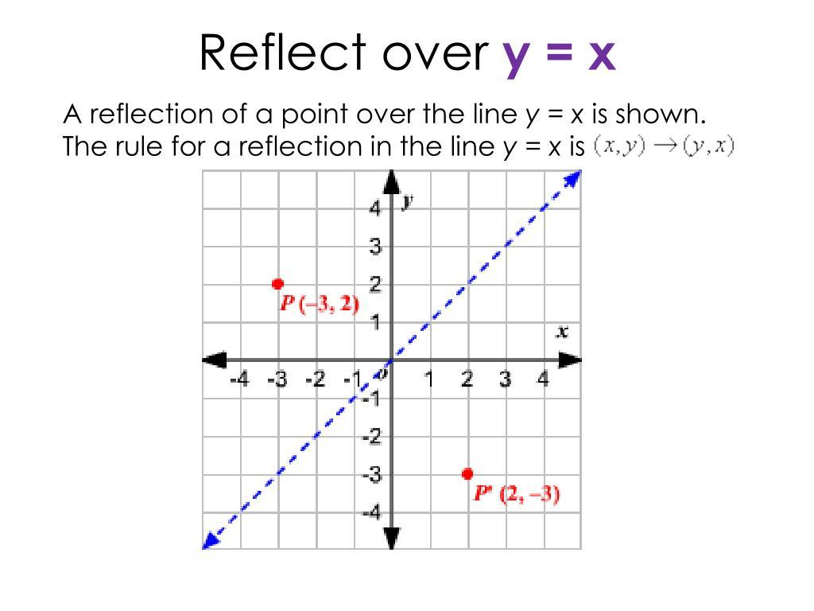
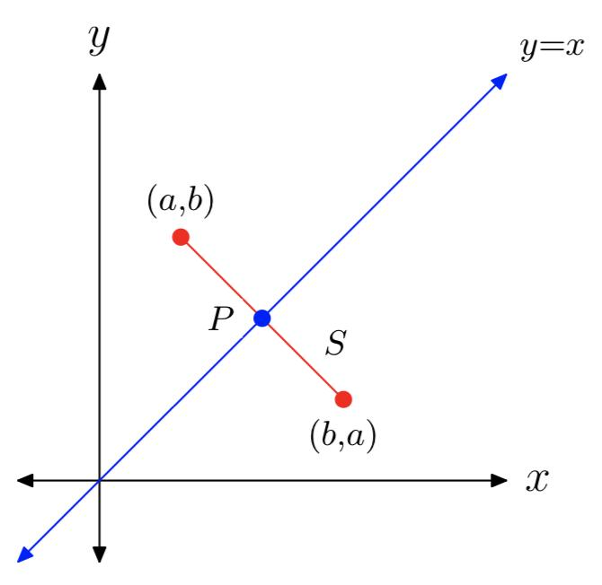
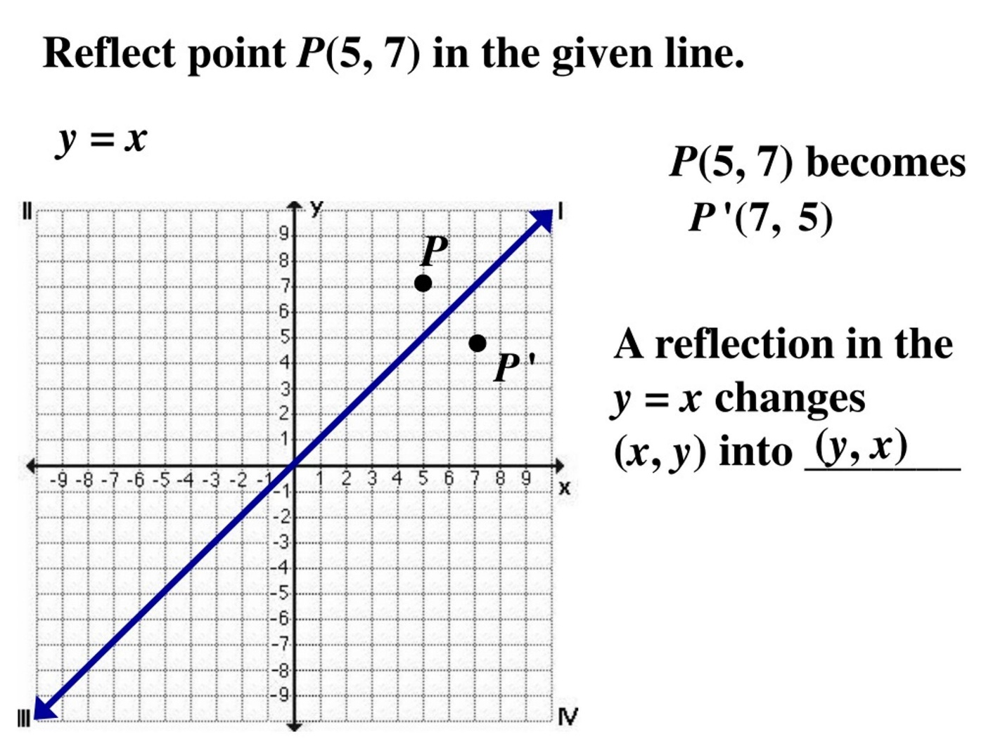

Line Symmetry of Functions
# Source: AI Source: Provided by: [Data Path: Persons Table -> ID Column: 1, Name_En Column: Motasem Essam] -> From: [ChatGPT] on [7/25/2026]
In coordinate geometry, a graph can have symmetry about a line.
For example, an even function satisfies:
$$\boxed{f\left(-x\right)=f\left(x\right)}$$
This produces symmetry about the $y$-axis.
A common example is:
$$y=x^{2}$$
because:
$$f\left(-x\right)={\left(-x\right)}^{2}=x^{2}=f\left(x\right)$$
Therefore, the parabola has line symmetry about the $y$-axis.
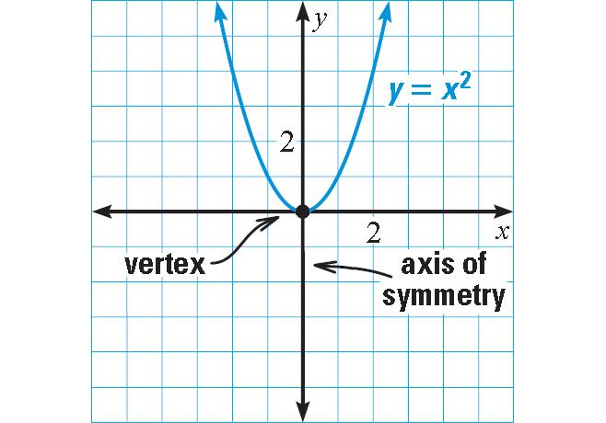
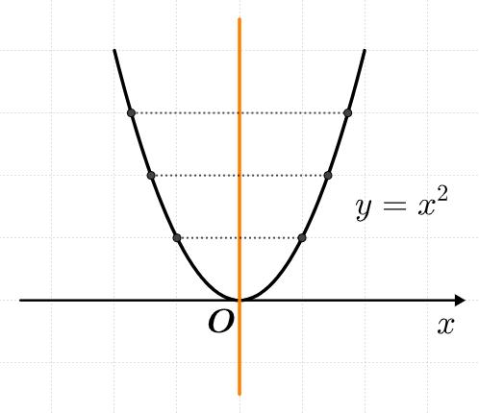
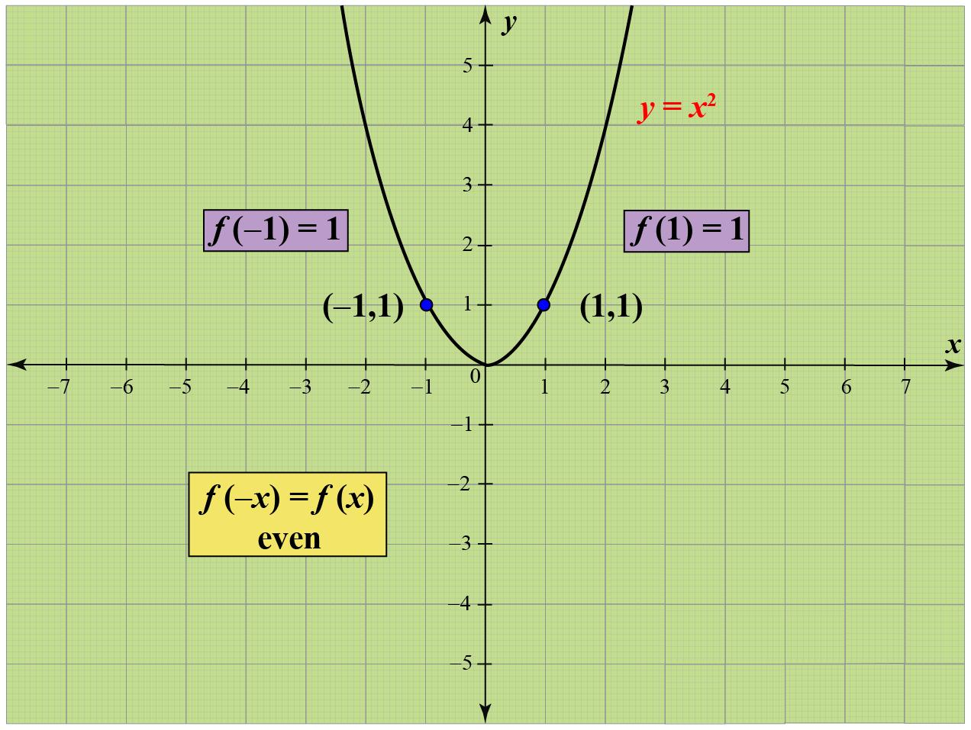
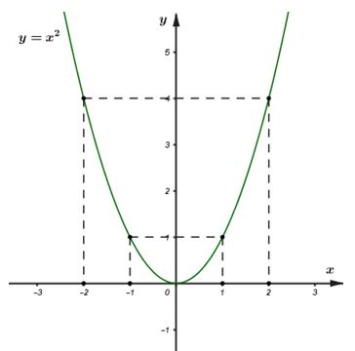
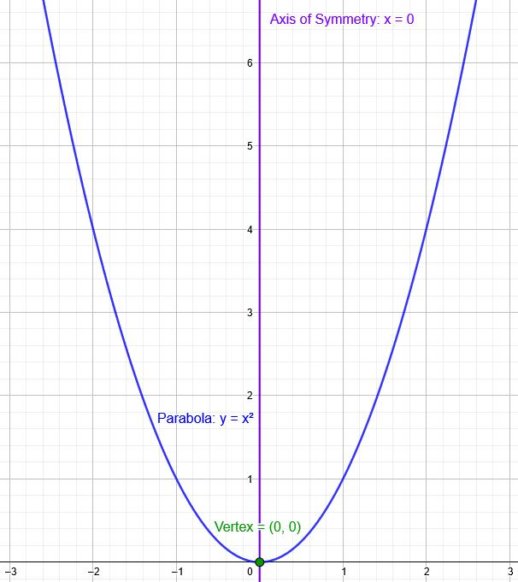

Line Symmetry vs Rotational Symmetry
# Source: AI Source: Provided by: [Data Path: Persons Table -> ID Column: 1, Name_En Column: Motasem Essam] -> From: [ChatGPT] on [7/25/2026]
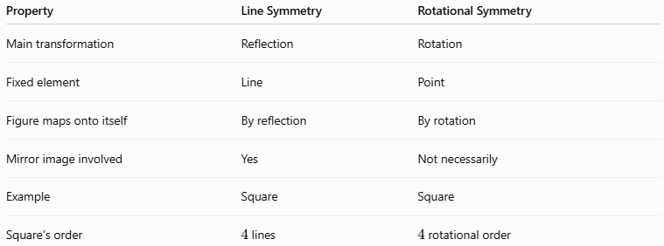
Property | Line Symmetry | Rotational Symmetry
Main transformation | Reflection | Rotation
Fixed element | Line | Point
Figure maps onto itself | By reflection | By rotation
Mirror image involved | Yes | Not necessarily
Example | Square | Square
Square's order | $4$ lines | $4$ rotational order
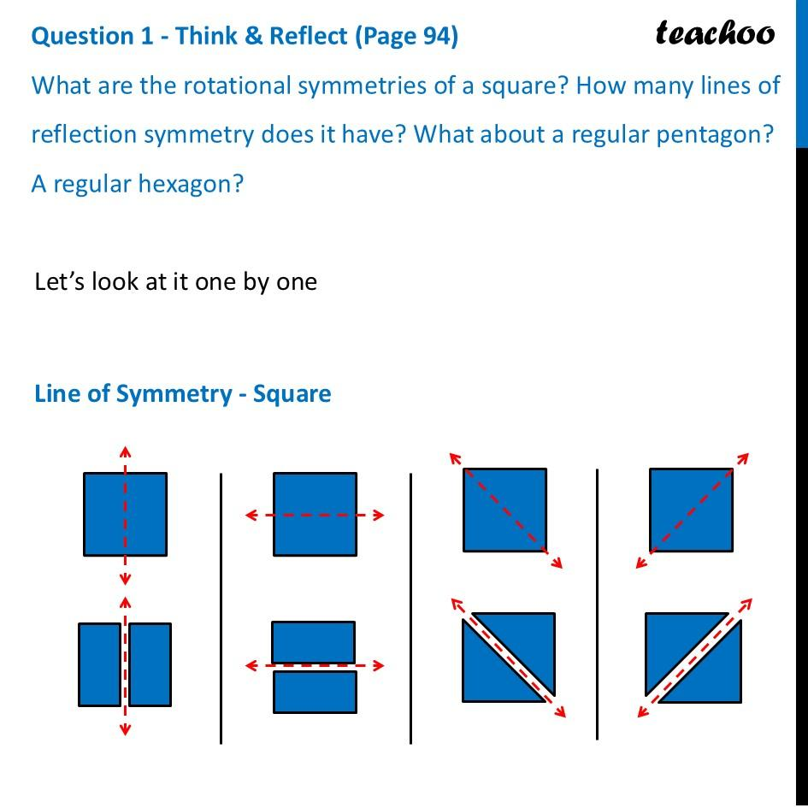
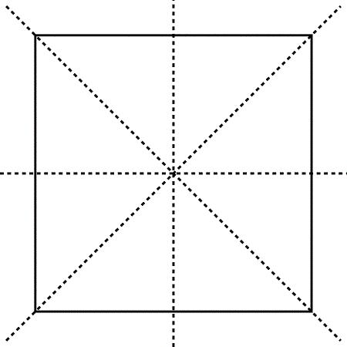
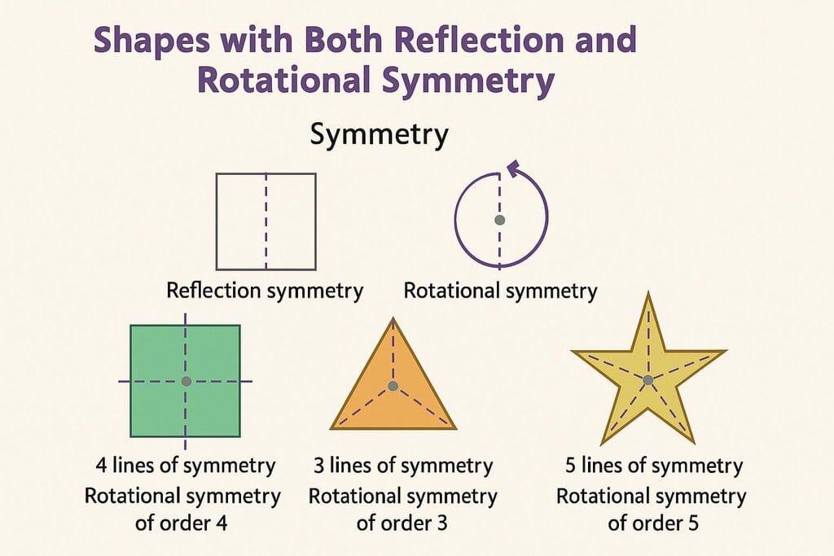

Line Symmetry vs Point Symmetry
# Source: AI Source: Provided by: [Data Path: Persons Table -> ID Column: 1, Name_En Column: Motasem Essam] -> From: [ChatGPT] on [7/25/2026]
Line symmetry uses reflection across a line.
Point symmetry uses a ${180}^{∘}$ rotation around a point.
$$\boxed{\text{Line Symmetry}→\text{Reflection}} \\ \boxed{\text{Point Symmetry}→{180}^{∘}\text{ Rotation}}$$

Line Symmetry and Congruence
# Source: AI Source: Provided by: [Data Path: Persons Table -> ID Column: 1, Name_En Column: Motasem Essam] -> From: [ChatGPT] on [7/25/2026]
When a figure is reflected across its line of symmetry, the two corresponding halves are congruent.
For example, if a line $L$ divides a figure into two symmetric parts:
$$\boxed{{\text{Part}}_{1}≅{\text{Part}}_{2}}$$
This is because reflection preserves:
- Length.
- Angle.
- Shape.
- Area.

Line Symmetry in Nature
# Source: AI Source: Provided by: [Data Path: Persons Table -> ID Column: 1, Name_En Column: Motasem Essam] -> From: [ChatGPT] on [7/25/2026]
Line symmetry can be observed in many natural objects.
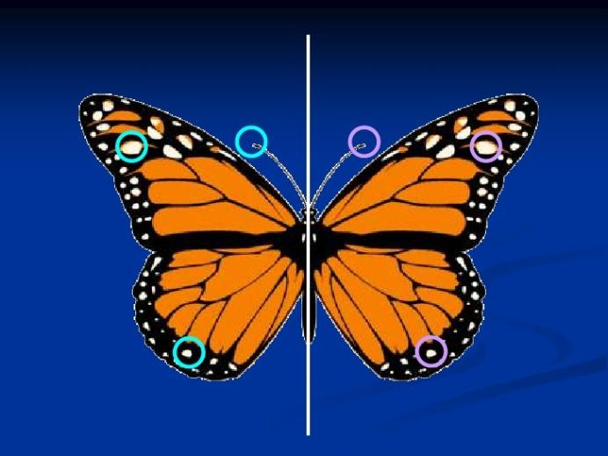
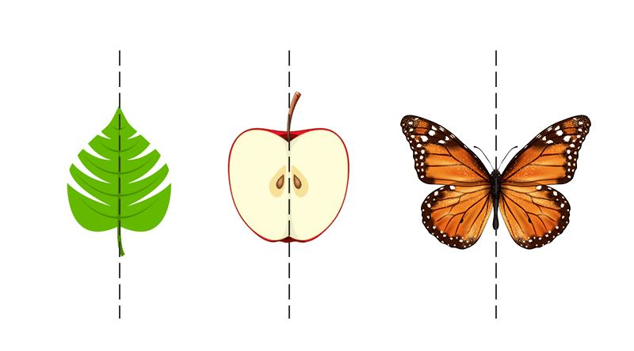

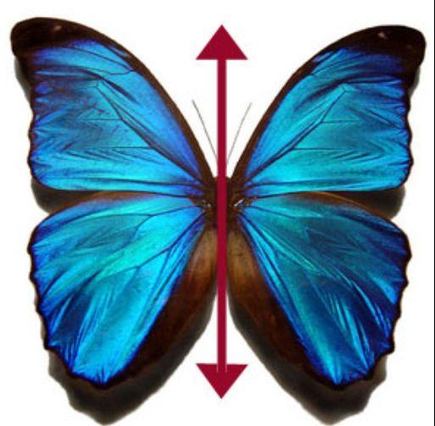
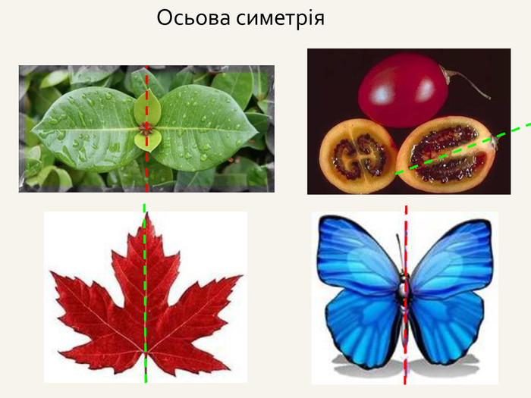
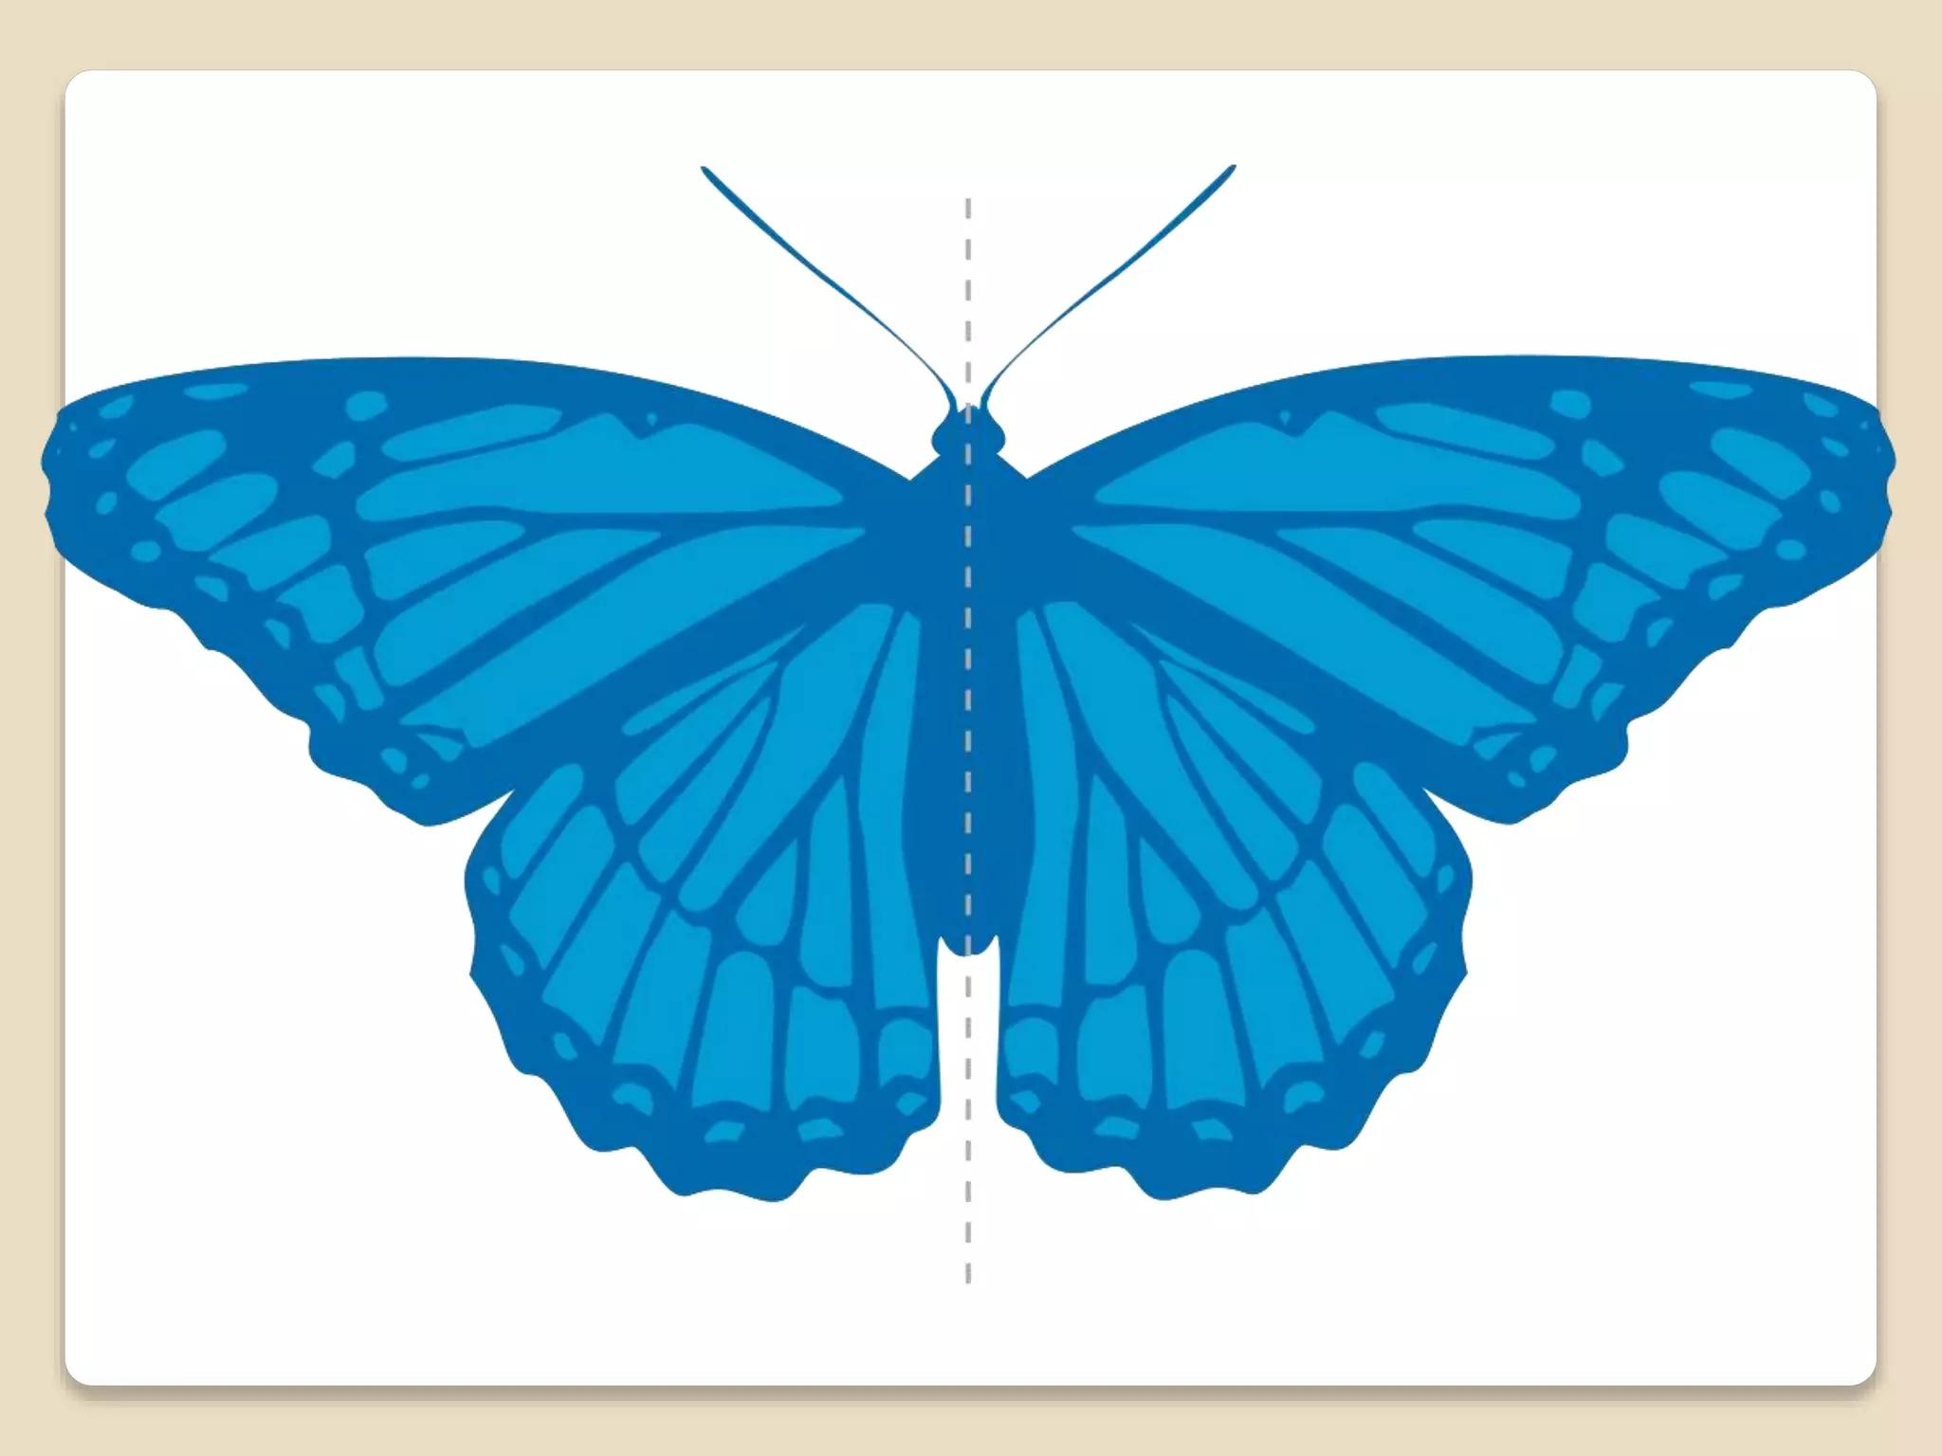
Examples include:
- Butterflies.
- Leaves.
- Some flowers.
- Many animals.
- Human body structure.
Natural symmetry is often approximate rather than perfectly mathematical.

Line Symmetry in Architecture and Design
# Source: AI Source: Provided by: [Data Path: Persons Table -> ID Column: 1, Name_En Column: Motasem Essam] -> From: [ChatGPT] on [7/25/2026]
Line symmetry is commonly used to create balanced structures.
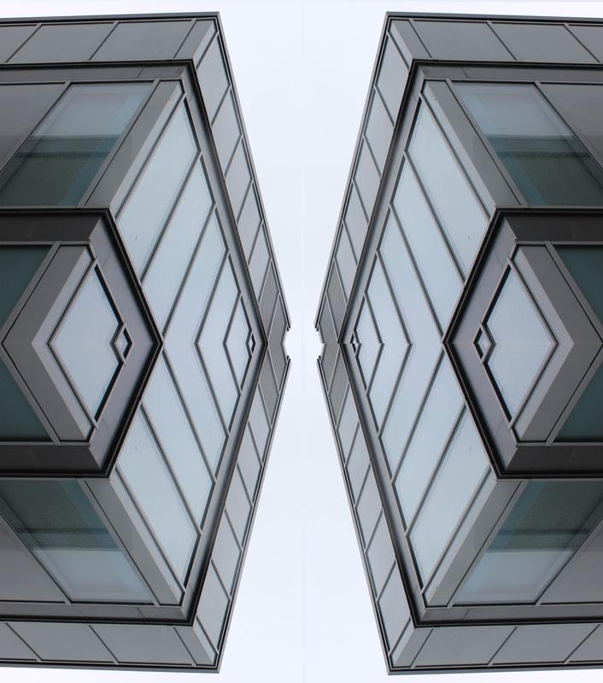

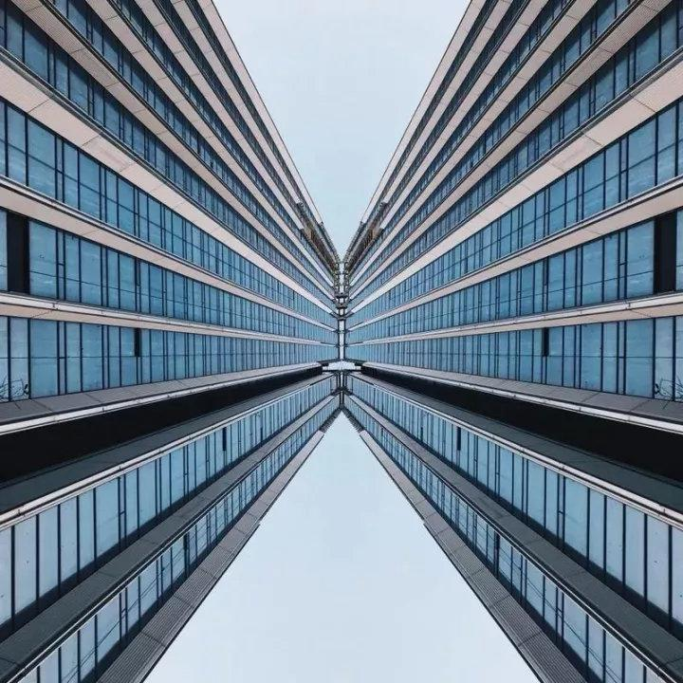


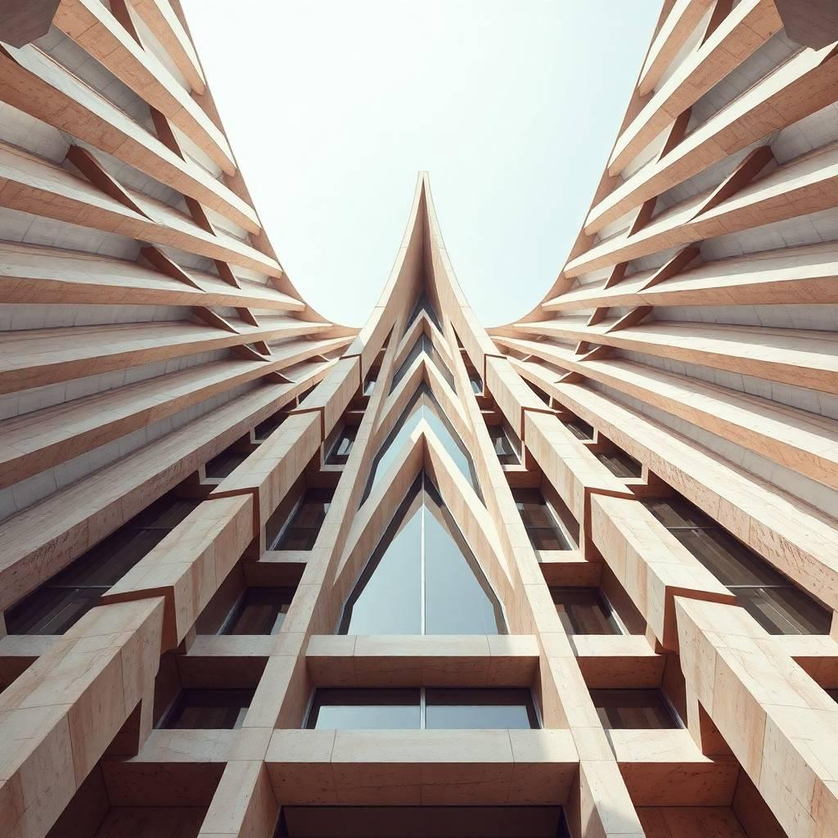
Applications include:
- Building facades.
- Doors.
- Windows.
- Bridges.
- Decorative patterns.
- Logos.
- Furniture.
- Product design.

Line Symmetry in Computer Graphics
# Source: AI Source: Provided by: [Data Path: Persons Table -> ID Column: 1, Name_En Column: Motasem Essam] -> From: [ChatGPT] on [7/25/2026]
Computer graphics and CAD systems use reflection to create symmetric objects.
For example:
- Create one half of an object.
- Select the symmetry axis.
- Reflect the first half.
- Combine the two halves.
This is called mirror modeling.
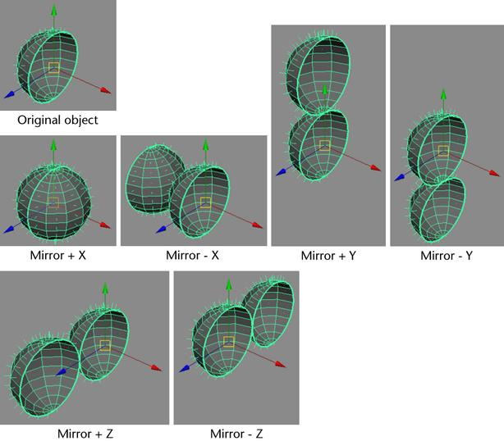
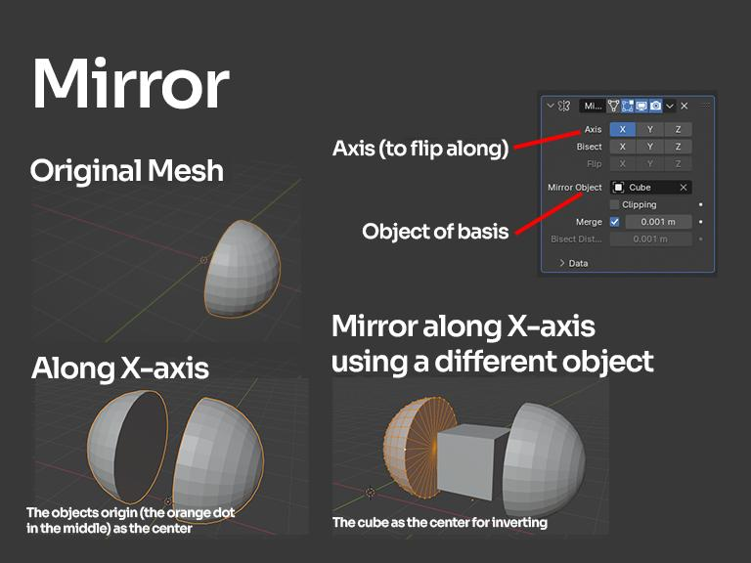
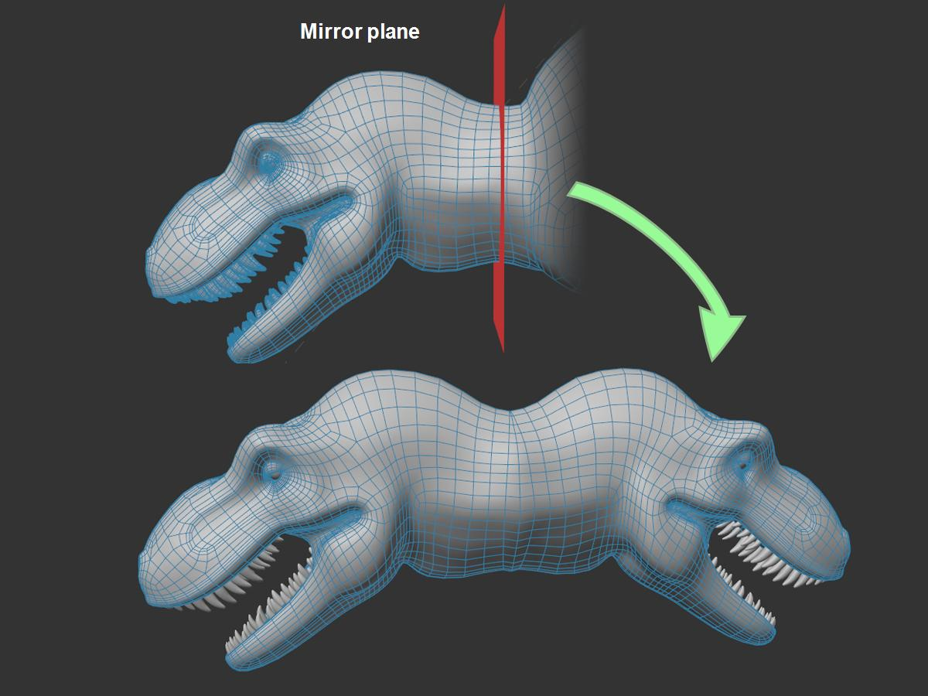
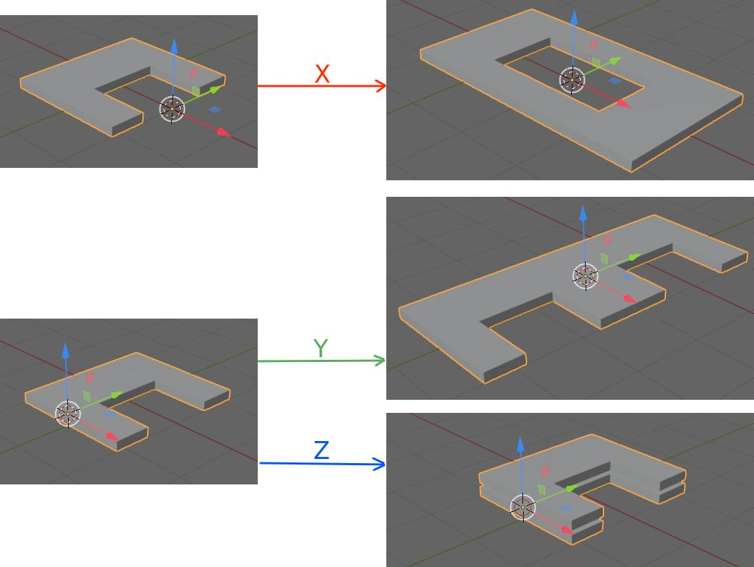
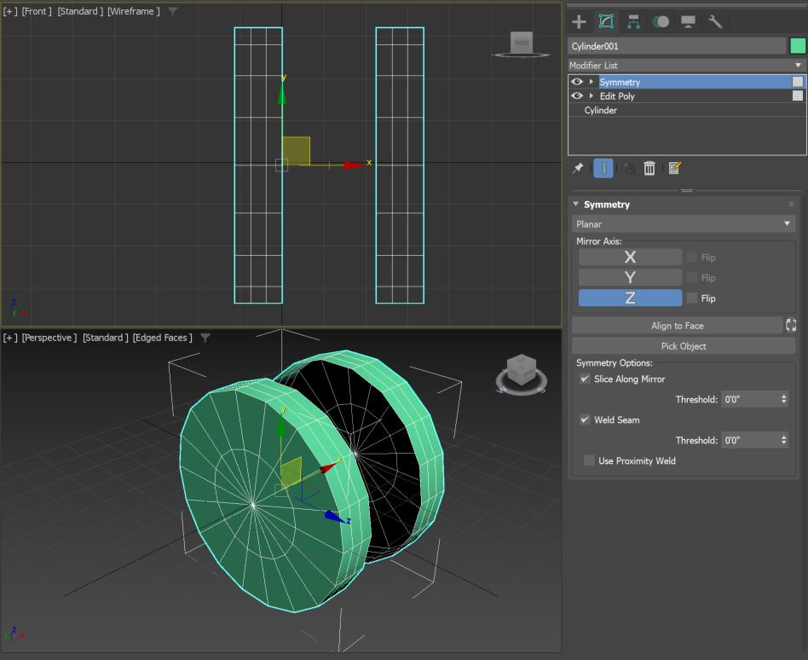
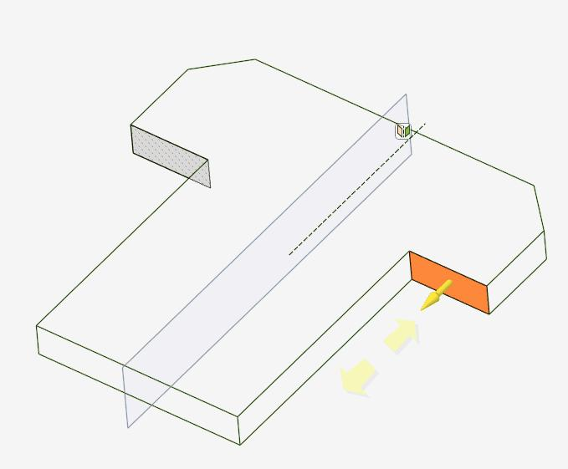

Applications
# Source: AI Source: Provided by: [Data Path: Persons Table -> ID Column: 1, Name_En Column: Motasem Essam] -> From: [ChatGPT] on [7/25/2026]
Line symmetry is important in:
- Plane Geometry
- Geometric Transformations
- Coordinate Geometry
- Architecture
- Engineering
- CAD
- Computer Graphics
- Product Design
- Art
- Pattern Design
- Biology
- Crystallography

Advantages
# Source: AI Source: Provided by: [Data Path: Persons Table -> ID Column: 1, Name_En Column: Motasem Essam] -> From: [ChatGPT] on [7/25/2026]
Studying line symmetry helps to:
- Recognize balanced figures.
- Understand reflection.
- Identify corresponding points.
- Analyze geometric shapes.
- Simplify geometric constructions.
- Create symmetrical designs.
- Understand coordinate transformations.
- Develop spatial reasoning.
- Support CAD and computer modeling.

Limitations
# Source: AI Source: Provided by: [Data Path: Persons Table -> ID Column: 1, Name_En Column: Motasem Essam] -> From: [ChatGPT] on [7/25/2026]
Line symmetry:
- Does not exist in every geometric figure.
- May be absent in irregular shapes.
- Real-world objects may only be approximately symmetric.
- Some figures can have many lines of symmetry, making analysis more complex.
- Line symmetry alone does not describe rotational or point symmetry.

Comparison with Related Concepts
# Source: AI Source: Provided by: [Data Path: Persons Table -> ID Column: 1, Name_En Column: Motasem Essam] -> From: [ChatGPT] on [7/25/2026]
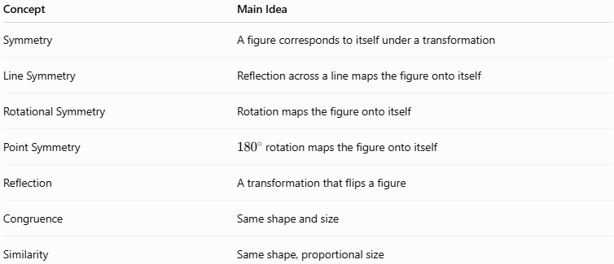
Concept | Main Idea
Symmetry | A figure corresponds to itself under a transformation
Line Symmetry | Reflection across a line maps the figure onto itself
Rotational Symmetry | Rotation maps the figure onto itself
Point Symmetry | ${180}^{∘}$ rotation maps the figure onto itself
Reflection | A transformation that flips a figure
Congruence | Same shape and size
Similarity | Same shape, proportional size

Key Points
# Source: AI Source: Provided by: [Data Path: Persons Table -> ID Column: 1, Name_En Column: Motasem Essam] -> From: [ChatGPT] on [7/25/2026]
- Line Symmetry is a type of geometric symmetry based on reflection.
- The dividing line is called the line of symmetry or axis of symmetry.
- The two sides of the figure are mirror images.
- Corresponding points are the same distance from the symmetry line.
- The segment connecting corresponding points is perpendicular to the symmetry line.
- Reflection preserves size and shape.
- Therefore, reflected parts are congruent.
- A regular polygon with $n$ sides has:
$$\boxed{n}$$lines of symmetry.
- A circle has:
$$\boxed{∞}$$lines of symmetry.
- Line symmetry is widely used in geometry, architecture, engineering, CAD, art, nature, and computer graphics.

Conclusion
# Source: AI Source: Provided by: [Data Path: Persons Table -> ID Column: 1, Name_En Column: Motasem Essam] -> From: [ChatGPT] on [7/25/2026]
Line Symmetry is a type of Geometric Symmetry in which a figure can be divided by a line into two matching mirror-image parts. The line is called the line of symmetry or axis of symmetry. It is mathematically connected to the reflection transformation, where corresponding points remain the same distance from the symmetry line and the resulting figure remains congruent to the original. Line symmetry is fundamental to the study of geometric figures, transformations, coordinate geometry, architecture, engineering, design, nature, and computer graphics.

